Worksheet MP-2 Population Changes in a Mining Town
MP-2 Interactive Map
Directions: Do the Step and then the Task for that Step before moving on
to the next Step and Task
Step 1 | Your Task
A. Click on the link or copy and paste the link into your browser to see more detail of the picture of the miner’s log cabin to the right:  http://www.unco.edu/hewit/doing-history/colorado-miners/food-clothing-shelter/shelter.aspx | 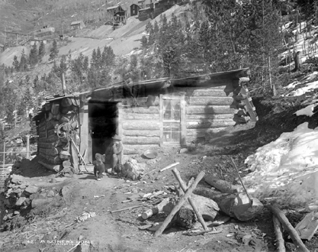  Photo: Colorado Historical Society  1. Using your historical detective eye, examine the photo of this miner’s log cabin in the 1860’s.  What things do you notice about the geography of the land?  What natural resources do you see?  What other things do you notice in the picture?  Discuss with your partner and write down your observations in the space below:
Step 2 | Your Task
B. Click on the link or copy and paste the link into your browser to see more detail of the picture of Central City, one of the first Mining Towns on the right.  http://www.unco.edu/hewit/doing-history/colorado-miners/mining-towns/central-city.aspx | 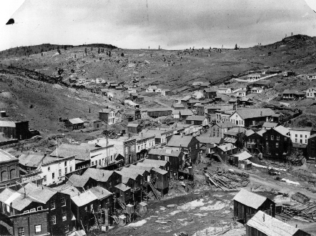  Photo: Colorado Historical Society  2. Using your historical detective eye again, look at this photo of Central City, one of the first mining towns in Colorado.  What things do you notice about the geography of the land?  How does the geography of this area compare to the miner’s log cabin photo?  What natural resources do you see?  What other things do you see?  What is different? What is the same?  Discuss with your partner and write down your observations.
Step 3 | Your Task
C. Open the online Map. In a browser go to (or click link):  http://unco.maps.arcgis.com/apps/webappviewer/index.html?id=aeed10c185bd4dfcb11570d2da24cc28  D. Use the Layer List button to check on ONLY the following layers:  -1880 Counties  -Mining Camps and Ghost Towns  -Check OFF any other layers.  E. Do Task #3, 4, & 5 | 3. You are going to now gather data and compare population changes from the same County in Colorado during 1880, 1900, and 1930. Your teacher will assign you a County. Write the name of your County on the line below.  4. Find your county on the map. Click on counties to get a pop up window of its name. Make sure NOT to click on a mining camp. You can use the zoom in/out tools to see your county close up.  5. Click carefully on each Mining Camps/Ghost Town and find 3 mining camps/ghost towns in your County. You will see that mining camps and ghost towns are in the same layer on the map. That is because most ghost towns started out as mining camps.  Write 3 names of the Mining Camps/Ghost Towns in your County below. (Not all Counties will have 3 Mining Camps/Ghost Towns)  *  *  *  6. Follow Step F for your next Task #7.
Step 4 | Your Task
F. Click on your County on the map to bring up its pop up box.  -CHECK ON only 1880. No other year layers should be on. Record the population data in the chart.  -CHECK OFF 1880.  -CHECK ON 1900. Record the data in the chart.  -Then CHECK OFF 1900.  -CHECK ON 1930. Record the data in the chart.  G. Use this area for work space for Task #7 calculations, if needed: | 7. In the chart below, you will see three years: 1880, 1900, and 1930. For each year you will fill out the population information by checking off and on the layer needed for that year on the map.  See Step F.  Population Data for:_______________________ (Your County)  County Name Total Population Male Population Female Population Male & Female Population Difference  1880  1900  1930  8. Answer the questions below using the data from your chart:  - What year was the population the smallest?  - Why do you think this was the smallest at this time?  - What year was the population the greatest?  - Why do you think this was the greatest at this time?  - What year was the difference between the number of men and women the greatest?  - Did the percentage of male to female change? If so, why do you think the county would have changed?  - What do you think caused the changes in population in Colorado mining areas between 1880 and 1930?  - If you could choose a year to have lived in a Colorado Mining Camp, which year would you choose and why?  Write your reasons below.

