Worksheet MP-1 Colorado’s Mining Regions
MP-1 Interactive Map
Directions: Do the Step and then the Task for that Step before moving on
to the next Step and Task.
Step 1 | Your Task
A. In a browser go to (or click link):  http://unco.maps.arcgis.com/apps/webappviewer/index.html?id=aeed10c185bd4dfcb11570d2da24cc28  B. Complete Task #1 & #2 (on your right). | 1.This online map shows the Colorado Mountain Region, early trails, and mineral belt before the gold rush began in Colorado.  2. Look at the Legend and familiarize yourself with the key and its symbols. In pencil, label one spot on the map for each: an early trail, mountains, the mineral belt and one of the sides of the Colorado border.  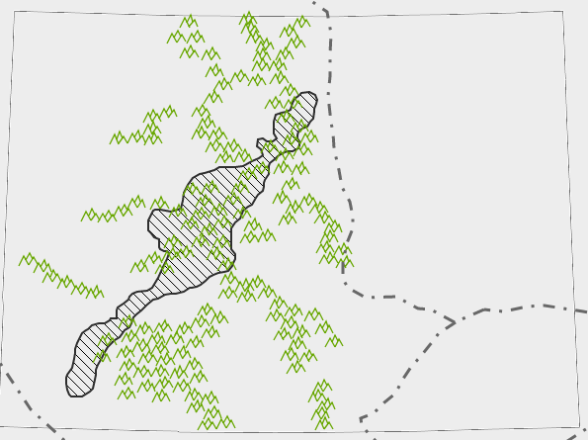
Step 2 | Your Task
C. Close the Legend box (X) on online map.  D. Complete Task #3 | 3. Make a prediction of the length and width of the Mineral Belt in miles on the map.  Prediction-Length of Mineral Belt: miles  Prediction-Width of Mineral Belt: miles
Step 3 | Your Task
E. Click on the ruler icon at the top left to open Measurement box.  F. Click on the middle icon labeled Distance and choose Miles from dropdown.  G. Click on one end of the Mineral Belt.  -A green marker will appear. -Now click on the other end of the Mineral Belt for ending point and another green marker will appear with a blue line between the two points.  -This will calculate the distance between these two points.  -Your total mileage will show in the Measurement box. Use the Clear button to start over or to recalculate. Or, close and the Measurement box to also clear measurements.  H. Complete Task #5 & #6. Record the actual mileage in the Task column. | 4. Do Steps E, F, G & H on map.  5. Using the Measurement Tool, now measure the actual length and width of the Mineral Belt in miles, making sure to find the farthest points from top to bottom for length and widest points across for width.  Actual Length of Mineral Belt: _____________miles  Actual Width of Mineral Belt: ______________miles  6. What was the difference between your prediction and what you found for the actual length and width of the Mineral Belt?  Difference in Length of Mineral Belt prediction and actual:  ___________miles  Difference in Width of Mineral Belt prediction and actual:  ___________miles  Work Space:

Step 4 | Your Task
7. Look below at the map of Colorado’s early trails, mountains, and mineral belt again. On this map, predict and draw in with a colored pencil where you think some of Colorado’s first mining camps might have been.

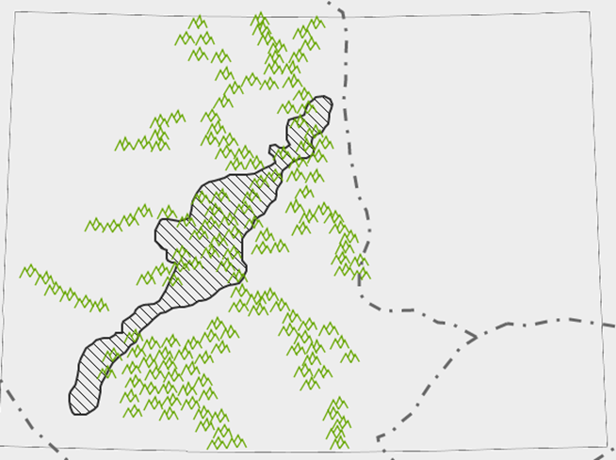

8. Why do you predict this location(s)? Discuss and record your reasons for your choices.

9. Make another prediction and draw in on the same map with another colored pencil where you think Colorado’s early mining trails were.

Step 5 | Your Task
I. Click on the Layer List button .  Check on the Mining Camps and Ghost Towns layer.  Check on the Gold Rush Trails layer.  J. Complete Task # 10 | 10. Compare your two estimates with the map: 1) where you thought the mining camps would be; and 2) where you thought the gold rush trails would be.  Are they both the same?  Are they different from each other?  If so, why?  If not, why?  Write your answers below and discuss with your partner.

