Worksheet R1. Activity Regions R1
Activity R1: Western Colorado

Step 1 | Your Task
The Regions (CEH) and 1920 County Boundaries layers are visible. Click the Legend button to see the legend for the 1900-1910 Pop. Change layer. You can also see the legend/symbols for individual layers by using the Layer List button and then clicking the side arrow next to a layer’s name. Feel free to move the Legend or Layer List box(es) to the side so you can see both the legend and most of the map.  According to  http://dictionary.kids.net.au/word/county  A county is:  a region created by territorial division for the purpose of local government; "the county has a population of 12,345 people"  the largest administrative district within a state; "the county plans to build a new road"  A region is:  the extended spatial location of something; "the farming regions of France"; "regions in all parts of the world"; "regions of outer space" | Identify at least ten counties that are entirely within the region of Western Colorado (click on each individual county).  Define Regions in your own words:  Define Counties in your own words:  About nine counties are divided between “Western Colorado” and other regions. Identify any four of these. Why do you think the regional boundary goes through these counties?
Step 2 | Your Task
Check ON the Major Mountain Ranges layer  Check OFF the Major Mountain Ranges and Check ON the Life Zones layer. Look at the legend or Life Zones.  Plains and Desert Southwest: 3,300 to 5,000ft above sea level.  Foothills Life Zone: 5,000 to 7,500 ft. above sea level.  Montane Life Zone: 7,500 to 10,500 ft. above sea level.  Subalpine Life Zone: 10,500 to 11,500 ft. above sea level.  Alpine Life Zone: 11,500 ft above sea level. | Which region has the most mountains?  Which two high elevation life zones are found more in Western Colorado than in any other region?
Step 3 | Your Task
Check ON the Major Rivers layer. Identify the Yampa, White and Colorado Rivers (in the western ½ of the state). Note: you may want to zoom into northwestern Colorado; and you need to precisely click on rivers to get the correct pop-up box. | Which general direction do the rivers flow? How do you know?  Write a sentence describing how the characteristics of the region called Western Colorado is different from the other regions of Colorado.
Step 4 | Your Task
Go to Doing History and investigate the following site:  http://hewit.unco.edu/dohist/trappers/themes.htm | What did the first European-Americans who came to Western Colorado do?  What do you think was the next economic activity that was important in Western Colorado?
Step 5 | Your Task
Make visible the Mineral Belt layer and Refresh Map.  More Information can be found at:  http://coloradogeologicalsurvey.org/mineral-resources/historic-mining-districts/ | How does the location of this feature relate to the boundaries of the Colorado regions?  What other economic activity might have been important in Western Colorado? Explain your thinking.
Step 6 | Your Task
Check ON the 1920 # of Farms layer. This is a proportional symbol layer of farms in each county in 1920. | Identify the seven counties in Western Colorado that have the most farms. Arrange the seven counties in numerical order from greatest to least.  Which county in Western Colorado has the most farms of all?
Step 7 | Your Task
Click on the layers an over-lay of Rivers, Life Zones, and 1920 Farms in order to see how they relate. | Describe how the location of farming in Western Colorado relates to the location of the Rivers and the Life Zones.
Step 8 | Your Task
Add the mineral belt layer then compare the location of farms in Western Colorado to the Mineral Belt.  Compare the location of farms in Western Colorado to the Mineral Belt. | Why do you think the counties in the Mineral Belt have fewer farms?  In which two Life Zones does Western Colorado appear to have the most farms?  In which three Life Zones is the Mineral Belt centered?
Step 9 | Your Task
Most geographers think Western Colorado could be divided in two regions, because of the difference between economies based on farming and economies based on mineral resources.  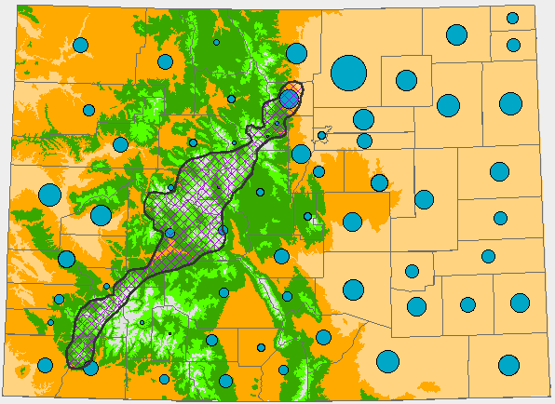  Now Check OFF all the open layers AND THEN Check ON the Present Regions? Layer. This shows one possible way to define that boundary. | If you were to divide Western Colorado into two regions, Use the map to draw or color in where you think that boundary should go:  How does the boundary you drew compare to the boundary on the Present Regions layer?

