Worksheet CB2. Activity County Boundaries CB2

Open Activity CB2: Early Colorado Counties.

Step 1 | Your Task
You will see a map of Colorado counties in 1880.  Open County Boundaries Activity CB2: Early Colorado Counties.  The red lines show where a county has been split into two or more counties. The labels represent the county names in 1890. If you use the Identify button the name of that county in 1880 should come up.  Check ON and OFF the 1890 County Boundaries layer and the Major Mountain Range layer to get a better idea of the changes. | Generally, what happened to the number of counties from 1880 to  1890?  In what three general areas did the county boundary changes occur?
Step 2 | Your Task
Check OFF the 1880 County Boundaries, and Check ON the 1890 County Boundaries layer.  Remember the Colorado life zones include:  Plains and Desert Southwest: 3,300 - 5,000ft above sea level.  Foothills Life Zone: 5,000 to 7,500 ft.  Montane Life Zone: 7,500 to 10,500 ft. above sea level.  Subalpine Life Zone: 10,500 to 11,500 ft.  Alpine Life Zone: 11,500 ft. above sea level and above.  Look at the 1895 Railroads layer. | Why do you think there were so many new counties formed in the Eastern Plains?  Did this have anything to do with the new counties?
Step 3 | Your Task
Check OFF all layers, Check ON 1890 County Boundaries.  (use the other layers to help answer the question). | During the 1880s why do you think there were a number of new counties formed on the Western Slope (Western Colorado)?
Step 4 | Your Task
Check OFF all layers, Check ON 1890 County Boundaries.  Links that may be helpful include:  https://www.southernute-nsn.gov/history/  https://www.southernute-nsn.gov/history/chronology/ | During the 1880s why do you think there were a number of new counties established in the mountains?
Step 5 | Your Task
Make sure the 1890 County Boundaries and 1880 County Boundaries layers are Checked ON. Go to your Bookmarks and select the Pitkin and Lake Counties bookmark. This should zoom you to this area of the state. If you need to you can zoom back out slightly (manually).  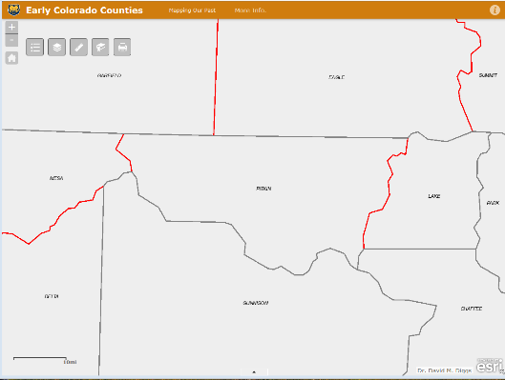  You can see where Lake County was divided into Lake and Pitkin. Actually, from 1880 to 1890 Lake County was split into 5 different counties (Lake, Pitkin, Mesa, Delta, and Montrose).  Check ON the Mining Camps and Ghost towns layer.  Click on the various town in Lake and Pitkin Counties (to obtain their popup boxes with name). Make sure you click “Precisely” on the towns, so that you get the popup box for the town (not the county). | Can you find the two “famous” mining towns in Lake and Pitkin counties?  In Lake County  ______________  In Pitkin County  _____________
Step 6 | Your Task
Click on the Measure tool, then select the distance tool, and measure the distance from these two famous mining settlements (click once on each town). When done close the Measurement box.  Use the Life Zones, Continental Divide, and Mountain layers.  Extra information can be found at: https://westernmininghistory.com/articles/11/page1/ | Distance in Miles.  Why didn’t these two mining settlements just remain together as one county?

