Understanding by Design Unit Template Guide

Title of Unit | Colorado Boundaries |  | Grade Level | Intermediate
Curriculum Area | Colorado Geography |  | Time Frame
Developed By
Identify Desired Results (Stage 1)
Content Standards
Standard: 1.1 History – Organize and sequence events to understand the concepts of chronology and cause and effect in the history of Colorado.
Standard:1.2 History – The historical eras, individuals, groups, ideas and themes in Colorado history and their relationships to key events in the United States.
Standard: 2.1 Geography - Use several types of geographic tools to answer questions about the geography of Colorado.
Standard: 2.2 Geography - Connections within and across human and physical systems are developed.
Standard: 3.1 Economics – People respond to positive and negative incentives.
Understandings |  |  | Essential Questions
- Individuals recognize important events and can put them in chronological in order to understand cause and effect such as migration west, discovery of gold and the Gold Rush, the growth of cities and towns.  - The context and information from the past is used to make connections and inform current decisions. For example, Colorado has had a history of boom and bust cycles that should influence the decisions of city and state planners.  - Technological developments continue to evolve and affect the present.  - Individuals and businesses learn how to use geographic tools to answer questions about their state and region to make informed choices. For example, a family reads a weather map and researches road conditions to inform their decision to go to the mountains in the winter.  - Individuals and businesses use geographic tools to collect and analyze data regarding the area where they live.  - Individuals and businesses consider geographic factors in making settlement decisions.  - Individuals and businesses adapt to and modify the environment. For example, businesses and resorts have been created near hot springs throughout the state.  - Positive incentives influence behavior predictably over time. For example, responsible individuals save for the future and move for better job opportunities.  - Negative incentives influence behavior predictably over time. For example, people move or refuse to relocate due to poor climate or resource shortages. |  |  | - How have past events influenced present day Colorado and the Rocky Mountain region?  - What social and economic decisions caused people to locate in various regions of Colorado?  - In what ways have geographic, economic, cultural, and technological changes influenced Colorado today?  - Why did people of various cultures migrate to and settle in Colorado?  - How have various individuals, groups, and ideas affected the development of Colorado?  - Which geographic tools are best to locate information about a place?  - Why did settlements and large cities develop where they did in Colorado?  - How are the regions of Colorado defined by geography?  - How does the physical location of Colorado affect its relationship with other regions of the United States and the world?  - What physical characteristics led various cultural groups to select the places they did for settlement in Colorado?  - How did Colorado settlers alter their environment to facilitate communication and transportation?  - How does the physical environment affect human activity?  - How does human activity affect the environment?  - Why are different goods and services important at different times in Colorado’s history?  - How have science and technology changed the economy of Colorado?  - How have natural, human, and capital resources had both positive and negative impacts on the development of Colorado?
Knowledge  Students will know…… |  |  | Skills  Students will be able to……
According to  http://dictionary.kids.net.au/word/county  A county is:  - A region created by territorial division for the purpose of local government; "the county has a population of 12,345 people"  - The largest administrative district within a state; "the county plans to build a new road"  - A region is:the extended spatial location of something; "the farming regions of France"; "regions in all parts of the world"; "regions of outer space"  The major life zones  - Prairie or grassland  - Semi-desert shrublands  - Foothills or woodlands  - Montane  - Subalpine  - Alpine  - Riparian  Major landforms of Colorado  - Great Plains  - Rocky Mountains  - Colorado Plateau  Major Rivers  - Colorado  - Rio Grande  - South Platte  - Arkansas River  Major Mountain Ranges  - Colorado Rocky Mountains  - Front Range  - Sangre de Cristo Mountains  - Sawatch Range  - San Juan Mountains |  |  | - Answer questions about Colorado regions using maps and other geographic tools (DOK 1-2)  - Use geographic grids to locate places on maps and images to answer questions (DOK 1-2)  - Create and investigate geographic questions about Colorado in relation to other places (DOK 1-3)  - Illustrate, using geographic tools, how places in Colorado have changed and developed over time due to human activity (DOK 1-4)  - Describe similarities and differences between the physical geography of Colorado and its neighboring states (DOK 1-2)  - Describe how the physical environment provides opportunities for and places constraints on human activities (DOK 1-2)  - Explain how physical environments influenced and limited immigration into the state (DOK 1-2)  - Analyze how people use geographic factors in creating settlements and have adapted to and modified the local physical environment (DOK 1-3)  - Describe how places in Colorado are connected by movement of goods and services and technology (DOK 1-2)
Assessment Evidence (Stage 2)
Performance Tasks: T |  |  | Other Evidence: OE
MapCo Boundaries Activity CB1
MapCo Boundaries Activity CB2
MapCo Boundaries Activity CB3
Write A Persuasive Essay
Write A Script
Produce A Commercial
Where Am I?
Region Venn Diagram
Colorado Map Making
Colorado Geopoly
Activities
Lesson 1: |  | MapCo Boundaries Activity CB1
Lesson 2: |  | MapCo Boundaries Activity CB2
Lesson 3: |  | MapCo Boundaries Activity CB3
Lesson 4: Write a Persuasive Essay | Students pick one of the Colorado regions. They will write a persuasive essay convincing someone why they would want to live in this region.
Lesson 5: Write a Script | Students will demonstrate their knowledge of Colorado regions and boundaries by pretending to be a tour guide and writing a script of what he/she would tell tourists.
Lesson 6: Produce a Commercial | Students will produce a commercial demonstrating their knowledge of Colorado regions and boundaries.
Lesson 7: Where Am I? | Students locate and provide information their hometown on the Map of Colorado provided.
Lesson 8: Colorado Map Making | Students create their own map of Colorado following the directions and template provided.
Lesson 9: Colorado Geopoly | Students demonstrate their knowledge of Colorado regions and boundaries by playing Colorado Geopoly.

From: Wiggins, Grant and J. McTighe. (1998). Understanding by Design, Association for Supervision and Curriculum Development

Worksheet CB1. Activity County Boundaries CB1 Key

Open County Boundaries Activity CB1:

Step 1 | Your Task
Colorado’s Border and Early County Boundaries. A map of Denver, 1880 Counties, and Early Trails is displayed.  These are the major trails in Colorado before the gold rush. Click precisely on the trails to get a popup box with the trail’s name (Not the 1880 county information). Zooming in can help you be more precise on where you are clicking!  Use the Layer List button to Check On (make visible) the Major Mountain Ranges layer. | What are the 3 main trails that existed prior to the Colorado Gold Rush?  - Old Spanish  - Cherokee  - Santa Fe  Why didn’t these trails just head straight across the state from east to west?  The Colorado Rockies were too difficult to get over. Students could focus on the Cherokee Trail in particular to note that it avoided the Central Rockies in its path.
Step 2 | Your Task
Use the Layer List button to Check Off the 1880 Counties layer. Then Check On the 1876 Counties layer. At the bottom of the map you’ll see a small arrow. Click on this and you should see an attribute table of data. 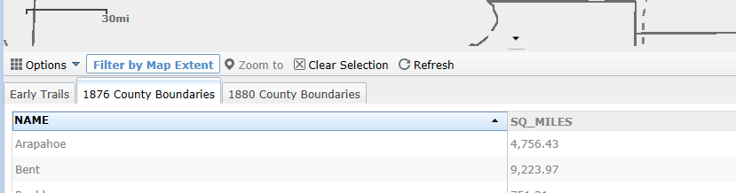  Click On the 1876 County Boundaries tab. Then Click On the Sq_Miles field heading. This should sort the table lowest to highest or highest to lowest. Get the table so it shows LOWEST to HIGHEST. Then hold down the Ctrl key and Click on the two counties that are UNDER 500 square miles in size. This should turn the outlines of the counties cyan in color. On the map it should look like:  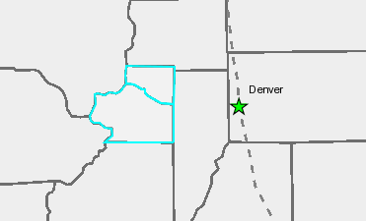  Turn on the Mineral Belt layer.  Turn on the Mountains Layer. | What two counties were chosen and what were their sizes?  Name Size in Sq. Miles  Clear Creek 400.89  Gilpin 154.27  Why do you think Colorado’s counties were such different sizes in 1876?  The purpose of this exercise is to draw student attention to the counties that, at statehood, already had sufficient settlement to warrant being separate, small service centers. (Students can probably also just spot these visually if asked, “Which two counties are the smallest?”)
Step 3 | Your Task
On the table click the Clear Selection button . You can also collapse the table (click on the small arrow). Check OFF ALL layers. Then Check On only the Major Rivers, Gold Rush Trails, 1876 Counties, 1879 Railroads, and Mineral Belt layers. | How did people reach these important mining counties?  These show that the major trails to the gold fields, and then the rail lines that came later, both followed the river valleys. Emphasize the importance of following water and the idea that river valleys themselves provide the path of least resistance into the mountains, because they are at lower elevations and carve canyons through the mountain barrier. (Not all trails and rails followed rivers, but most did – and the ones that appear not to often followed smaller rivers that are not included on our map layer.)
Step 4 | Your Task
Try turning on some of the other layers.  Check ON the Continental Divide layer. | Can you think of other factors that influenced the placement of county boundaries in 1876?  Allow speculation. Especially in the northern part of the state (site of earliest mining settlements), the physical barrier of the Divide corresponded to many borders. This question also foreshadows the analysis of splitting Lake and Pitkin Counties (Activity 2).  Note: The existence of the other counties around the state, especially the large ones in the south whose borders don’t follow physical features, can stimulate questions. The point is that prior to statehood, Colorado was split into several administrative divisions, which became the basis for the later counties.
Step 5 | Your Task
From the previous question you may have different layers on. So let’s get everyone back on the same page! Check OFF ALL layers, then Check On 1876 Counties. Look at this map for a second.  Now Check On the 1880 Counties layer. The Red lines indicate county boundary changes or the splitting of one county into two counties from 1876 to 1880.  Click on the Mineral Belt layer for additional help. | How many “more” counties were created by 1880?  5  (26 in 1876 and 31 in 1880)  Using the layers available on your map (and any other sources), try and form a “hypothesis” on WHY one of the counties was split into two or more counties.  Stress that the division of counties reflects increases in population from new settlements.  Have students consider why there was enough population growth in these areas to warrant the new county formation. They can formulate a hypothesis and then make visible the Mining Camps layer to see the density of camps in the areas that saw new county formation – reflecting the boom in mining in the southwestern mountains. Higher grade students could be asked to estimate the proportion (approximate percentage) of Mining Camps within the Mineral Belt.

Worksheet CB2. Activity Boundaries CB2 Key

Open Activity CB2: Early Colorado Counties

Step 1 | Your Task
You will see a map of Colorado counties in 1880.  Open County Boundaries Activity R2: Early Colorado Counties.  The red lines show where a county has been split into two or more counties. The labels represent the county names in 1890. If you use the Identify button the name of that county in 1880 should come up.  Check ON and OFF the 1890 County Boundaries layer and the Major Mountain Range layer to get a better idea of the changes. | Generally, what happened to the number of counties from 1880 to  1890?  They increased.  In what three general areas did the county boundary changes occur?  - Eastern Plains  - Western Slope (Western Colorado)  - Some areas in the Mountains
Step 2 | Your Task
Check OFF the 1880 County Boundaries, and Check ON the 1890 County Boundaries layer.  Remember the Colorado life zones include:  Plains and Desert Southwest: 3,300 - 5,000ft above sea level.  Foothills Life Zone: 5,000 to 7,500 ft.  Montane Life Zone: 7,500 to 10,500 ft. above sea level.  Subalpine Life Zone: 10,500 to 11,500 ft.  Alpine Life Zone: 11,500 ft above sea level and above.  Look at the 1895 Railroads layer. | Why do you think there were so many new counties formed in the Eastern Plains?  Have students speculate on why new counties were needed – focus on the reasons for new population centers on the Plains. The Better Soils layer shows the importance of agriculture in this region, emphasizing that this was a new use of land in Colorado to complement the mining settlements. Students can also look at the Life Zones layer and alternate looking at that layer and the Better Soils layer to note a general correspondence of soils suited for agriculture in the Plains. (One can’t really look at both at once, and in any case the Better Soils layer is partly defined on the basis of elevation, so the correspondence isn’t coincidental.)  Did this have anything to do with the new counties?  Students may be inclined to think that the railroads followed the establishment of new farming settlements; it was really the other way around. Different railroad companies built lines across the Plains to get a share of the lucrative minerals trade along the Front Range. Students can use the Identify button to count the number of different rail companies that built lines running east-west from the Kansas-Nebraska border to the mountains (at least five can be named). The farm towns sprung up along the different rail corridors. Of course the railroads also provided needed transportation—farmers in the Plains needed to get crops to market and miners in the mountains needed to get the minerals out.
Step 3 | Your Task
Check OFF all layers, Check ON 1890 County Boundaries.  (use the other layers to help answer the question). | During the 1880s why do you think there were a number of new counties formed on the Western Slope (Western Colorado)?  There were some good soils in portions of Western Colorado, although irrigation was necessary. Another factor not shown on the maps was the removal of the Ute Indians to reservations—thus opening the areas to settlement.
Step 4 | Your Task
Check OFF all layers, Check ON 1890 County Boundaries.  Links that may be helpful include:  https://www.southernute-nsn.gov/history/  https://www.southernute-nsn.gov/history/chronology/ | During the 1880s why do you think there were a number of new counties established in the mountains?  New silver and gold strikes were made in present-day Eagle, Summit, and Pitikin counties (and other areas). Some of these must have grown in population to the point where the areas warranted status as a “County”.
Step 5 | Your Task
Make sure the 1890 County Boundaries and 1880 County Boundaries layers are Checked ON. Go to your Bookmarks and select the Pitkin and Lake Counties bookmark. This should zoom you to this area of the state. If you need to you can zoom back out slightly (manually).  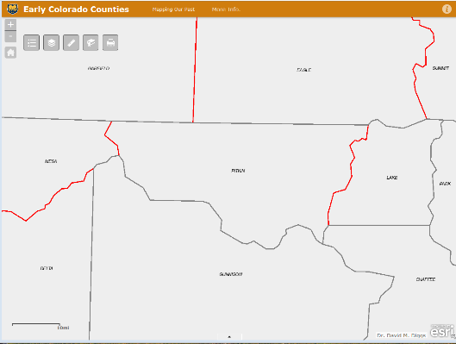  You can see where Lake County was divided into Lake and Pitkin. Actually, from 1880 to 1890 Lake County was split into 5 different counties (Lake, Pitkin, Mesa, Delta, and Montrose).  Check ON the Mining Camps and Ghost towns layer.  Click on the various town in Lake and Pitkin Counties (to obtain their popup boxes with name). Make sure you click “Precisely” on the towns, so that you get the popup box for the town (not the county). | Can you find the two “famous” mining towns in Lake and Pitkin counties?  In Lake County  Leadville  In Pitkin County  Aspen
Step 6 | Your Task
Click on the Measure tool, then select the distance tool, and measure the distance from these two famous mining settlements (click once on each town). When done close the Measurement box.  Use the Life Zones, Continental Divide, and Mountain layers.  Extra information can be found at: https://westernmininghistory.com/articles/11/page1/ | Distance in Miles.  25-30 miles  Why didn’t these two mining settlements just remain together as one county?  It would have been very difficult to get from Leadville directly to Aspen; the terrain was just too rugged and high.  Students can again re-measure the distance from Aspen to Leadville. What problems would people have encountered in making the trip? It’s about 28 miles in a straight line, but there were no good roads. People had to cross over the Continental Divide (lots of snow), and it was a long, arduous trip at this time. Creating two separate counties gave each mining area its own administrative service center.

Worksheet CB3. Activity County Boundaries CB3 Key
Open County Boundaries Activity CB3: 20th Century County Changes.

Step 1 | Your Task

From the middle bottom of the map bring up the table for your map; click on the 1890 County Boudaries tab, and then click on the “Name” field to get it in alphabetical order.

Then click on “ARAPAHOE” in the table. This should “select” the record and turn the county cyan on the map.
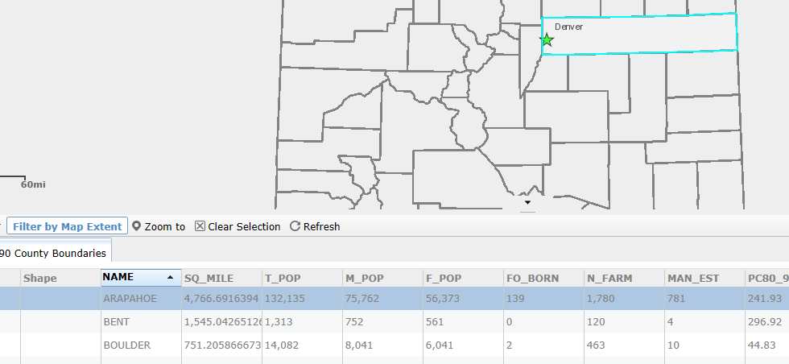

Now you know what Arapahoe County looked like in 1890—it stretched all the way from Denver to the Kansas border!

On the table click the Clear Selection button . You can also collapse the table (click on the small arrow). You now know the location of the old Arapahoe County.

Step 2 | Your Task
Check ON the 1920 County Boundaries layer (also—the 1890 County Boundaries layer should still be checked on). Go to the Bookmark “Northeastern Colorado”. If you want you can manually zoom in more/less to the area (depends on your monitor size). | From 1890 to 1920 Arapahoe County is split into 5 counties. What are they?  - Arapahoe  - Denver (although “Denver” was a city before this)  - Adams  - Washington (portions)  - Yuma (portions)
Step 3 | Your Task
Check OFF all layers then Check On the 1910-1920 Pop. Change layer. Go to the Bookmark “Colorado”. Make sure you look at the legend for this layer. | In terms of population growth, what happened in northwest and northeast Colorado from 1890 to 1920?  According to the “legend” these areas had “Large Gains” in population.  Why do you think Arapahoe County was split up into 5 different counties?  There were also continued population gains in the urban areas along the Front Range – keep in mind these already had relatively large populations, so in terms of percentage gain, they were smaller, but still represent significant growth of numbers. Ask students what most people on the Plains did for a living (this period was the time of homesteading in Eastern Colorado); and get them to consider whether the new populations farmers in the Plains would have had much in common with the established urban centers along the Front Range.  The division of Arapahoe County reflects this split between the urbanized western parts of the original county and the burgeoning farms of the east.
Step 4 | Your Task
Check OFF all layers. Then Check ON the following layers: 1920 County Boundaries, Communities, 1895 Railroads, and 1913 Railroads.  (you may want to zoom in a bit to Eastern Colorado) | How do you think railroads helped these new Plains counties (Eastern Colorado)?  Note the growth of the rail system in this era (prior to the importance of the automobile).  Have students talk about getting produce to market and being able to import finished goods (plows, cooking utensils, etc.) needed in the new towns. (This may be a good place to link to images and text from Doing History.)  Students may also note the regularity of the spacing between towns along the rail lines—this is looked at in the next question.
Step 5 | Your Task
Go to the Bookmark “Kit Carson County”. If you want you can manually zoom in more/less to the area (depends on your monitor size).  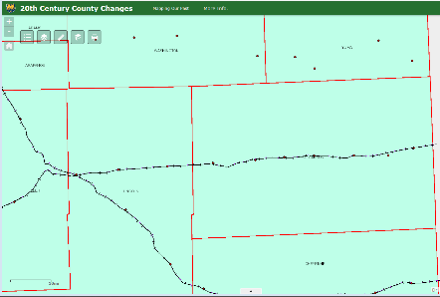  Click on the Measure tool, then select the distance tool, and measure the distance from town to town. Click once on the first town, a second click on the second town, then read the measurement.  Before starting the next pair of towns you’ll have to close the Measurement box and reopen it. | (Approximations)  Flagler to Seibert 10 miles  Seibert to Vona 7.5 miles  Vona to Stratton 7.5 miles  Stratton to Bethune 9.5 miles  Bethune to Burlington 8.4 miles  Burlington to Peconic 6.4 miles  What pattern do you notice about the distance between these towns? Why do you think towns were regularly spaced along the railroads?  The regularity of the distance suggests that the rail lines needed periodic stops for refueling or other services provided by each town. Students may note that some “strings” of communities do not appear to be served by rail. This is because some of the rail lines that these towns grew along were built after 1913, and some of these communities were served by the later highway system. (This problem crops up on the maps because the Communities layer includes all towns, not just those founded at a specific date.)  During the period 1890 to 1920 try to describe how Colorado’s economy was changing? (extended response)  This is an open-ended question. Answers will vary according to the amount of time you have spent on the topic with your students.  To summarize this set of activities, students should be able to recount how new counties were established to reflect new population centers. Such new centers arose originally in the mountains as new mining districts were opened and in the Front Range cities that provided access and services to the mines. Other projects we will develop can show the growth of manufacturing in these urban counties.  After the opening of rail connections across the Plains, farmers homesteaded the land, bringing a different economic activity to this part of the state. That can also be seen, to a smaller degree, in the valleys of the Colorado River and its tributaries in the westernmost counties of the state.  Finally, students can note the decline of mining in the state after the start of the 20th century. Have students make visible the Mineral Belt layer. The areas of declining population can be seen to correspond closely to the position of the Mineral Belt.

