Giant Traveling Map Lesson

TITLE / AUTHOR:
Colorado as Headwaters – Exploring Our Rivers / Sarah R. Johnson

COLORADO ACADEMIC STANDARDS / SUITABLE DISCIPLINES:
- Social Studies, Geography: Third Grade Standard 2, Grade Level Expectation 2: The concept of regions is developed through an understanding of similarities and differences in places, Evidence Outcome a: Observe and describe the physical characteristics and the cultural and human features of a region (DOK 1-2).
- Social Studies, Geography: Fourth Grade Standard 2, Grade Level Expectation 2: Use several types of geographic tools to answer questions about the geography of Colorado, Evidence Outcome a: Answer questions about Colorado regions using maps and other geographic tools (DOK 1-2).

OBJECTIVES:
Students will:
- be able to identify the spatial distribution of a river within its watershed in Colorado.
- use the Giant Map to answer questions about Colorado’s major river systems based on the river system’s unique characteristics.
- be able to determine the direction of flow of a river on a map from higher elevation to lower elevation.

RECOMMENDED GRADES: Third, Fourth, and Fifth Grades

TIME NEEDED: 30 minutes

MATERIALS:
- White board with dry erase markers
- Colorado’s major rivers card set with the name of one of the rivers on each card
- Eight lengths of chain

PREPARATION:
- Students have prior experience with using a map scale using the Map Scale and Measuring Distance lesson in the National Geographic State Giant Traveling Maps Lesson Handbook.

RULES:
- Shoes are not allowed on the map. Please have students remove shoes before walking on the map.
- No writing utensils on the map.
- No sliding on the map

DIRECTIONS:

Before you go to the giant state map: (optional segmentation of the lesson)
- Introduce students to the map, the scope and goals of the activity, and the rules and expectations.
- Review the online story map on Colorado’s Rivers created by Conservation Colorado. It provides a variety of photos and background information.
https://www.arcgis.com/apps/Cascade/index.html?appid=1a7e921c0a024a789711efaebf358cf0
- Using the white board introduce the concept of identifying which direction rivers flow (cardinal directions and downhill) using the following activity.
  - Draw a simple river system on the board (see example below) 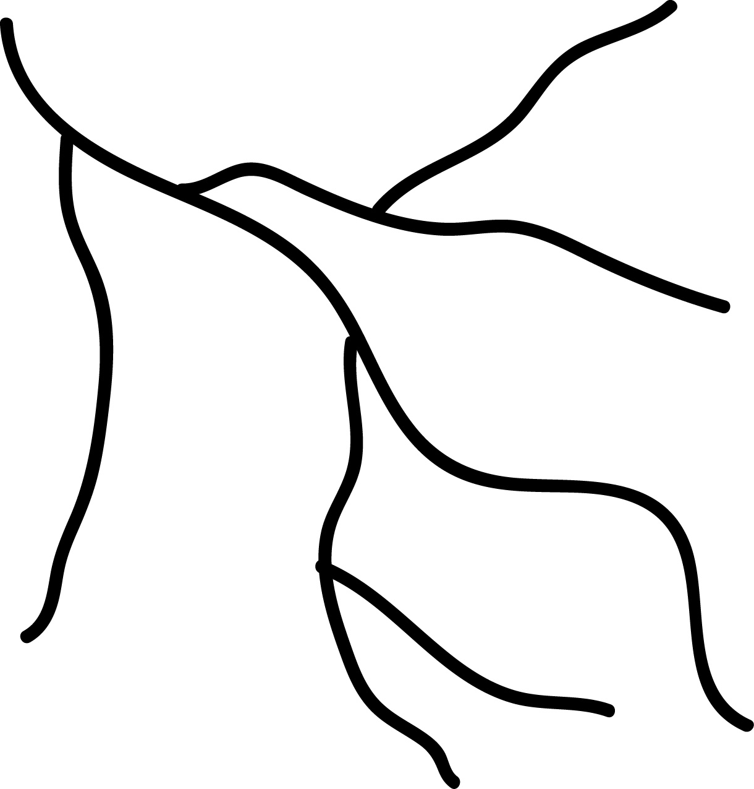

  - Then look for the V’s and draw them into the map with a different color marker (see example below).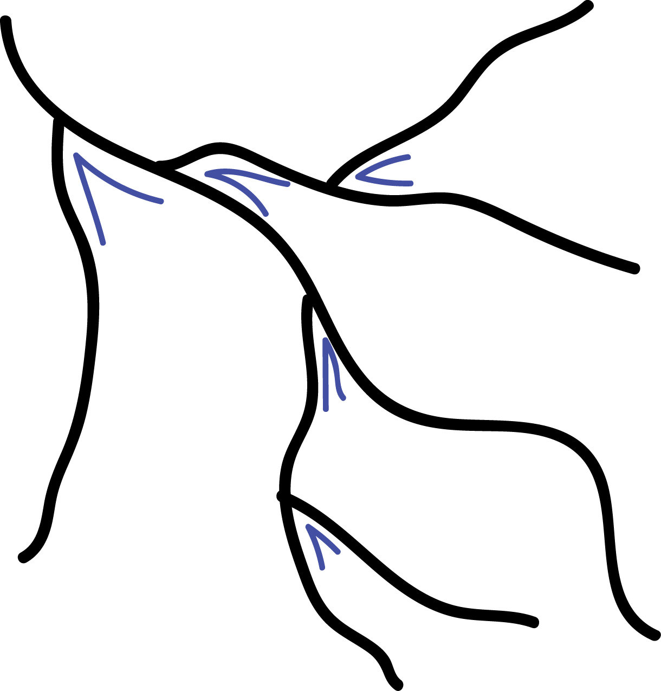

  - Finally, draw lines inside the V’s creating arrows as in the example below. Now the students can see that rivers flow toward each other creating V shapes on the landscape which ultimately point downstream. 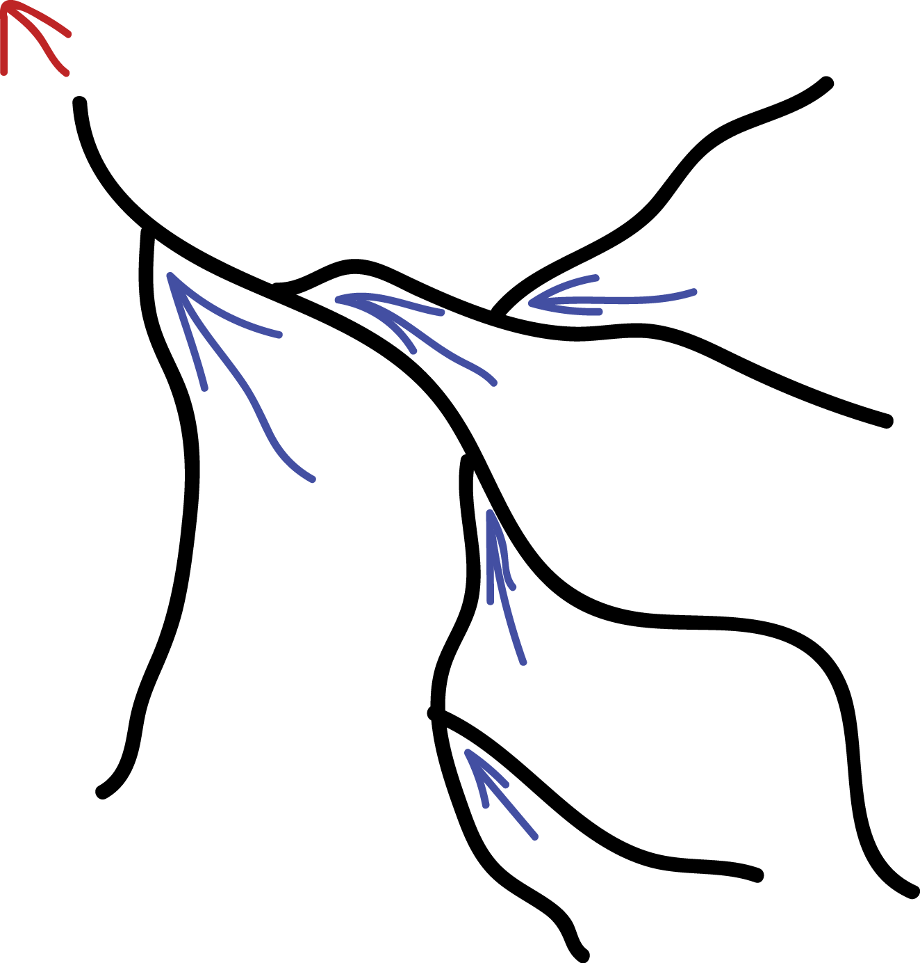

  - Draw a couple more examples on the board to ensure learner understanding before heading to the Giant Map. Identify the source of the rivers and the mouth.
  - Explain the definition of the word tributary as a smaller river or stream that contributes to the larger main stem.
  - Discuss that rivers flow downhill from higher elevation to lower elevation. Ask students to identify the high points on the simple river map on the board and the low points.

On the map: (optional segmenting of the lesson)
Identify Colorado’s 8 major rivers
- Invite students to take their shoes off, keeping their socks on, and to take a seat on the edge of the map.
- Group students into 8 groups of 2-3 students.
- Give each group a River Card and then invite them to find their river on the Giant Map and stand on it.
- Ask the students to trace their river with their finger from the source to the state boundary. Remind the students to look for the V’s to help them determine the cardinal direction flow of the river.
- Ask the students to all simultaneously point to the direction in which their river flows. Notice that every person is standing on the edge of the map because every river flows out of Colorado.
- Ask the students to consider where each of their rivers source is located. Do any of the 8 rivers begin outside of the Colorado boundary? Explain that Colorado is one of two headwaters states in the United States. A headwaters state is one that only has river originating within the state and no rivers that flow through it.
- Have each major river group trace the main stem of their river with one of the chains.
- Ask the students to then trace all the tributaries that contribute water to the main stem. While tracing, ask them to verbally say the names of each of the rivers they are tracing if there are place names included on the map.

Human Continental Divide
- Ask one participant from each group to put his or her finger on the source of the group’s river. Have the group take note of any similarities between the 8 rivers’ sources (they all begin near the Continental Divide). Revisit the discussion of rivers beginning up high in the mountains and flowing downhill to lower elevation.
- Have a couple students trace the Continental Divide (red dotted line) on the map. Ask the students if they notice any pattern related to the location of the source of their rivers and the location of the continental divide.
- Ask the students to then consider the direction of flow of their river in relation to the Continental Divide. Have the groups on the Eastern Slope (North Platte, South Platte, Arkansas, and Rio Grande) compare their direction of flow with each other. Also have the Western Slope groups (San Juan, Gunnison, Colorado, and Yampa) compare the direction of flow of their rivers.
- Finally, have the students line up facing south and standing over the continental divide, stretching their legs out as if they were the east and west sides of the ridge. Have the students raise their arms and put their hands together to make a mountain. Explain that the Continental Divide divides the continent’s topography and rivers and stream on the east side flow east toward the Atlantic and those on the west side flow toward the Pacific.

Final Discussion
- Ask the learners to find where they live on the map and stand at that location on the map. Ask them if they live near a river or stream. Is the learners’ river on the Giant Map, if so, have them locate it. If not, consider adding another colored rope or string to represent their river or stream. Create a label with the river’s name.
- Conclude with a discussion about how important rivers and streams are to each and every community across Colorado.

MODIFICATION:
Reasonable accommodations can be made based on the needs of each student.

EXTENSIONS:
- Measure the length of rivers within Colorado state boundary
  - Assuming the students have prior experience using map scale and determining distance, hand each group the appropriate chain for their river.
  - Invite each group to determine the length of their river within the state boundary of Colorado using the chain and the map scale.
  - Ask student groups to determine the length of each of the tributaries that contribute to their main stems. Have students add the lengths of their tributaries to the length of the main stem to get a total distance of river miles for their entire river system.
- Explore Project WET lessons http://www.projectwet.org/, for example, Seeing Watersheds and Blue River.
- Contact the Colorado Foundation for Water Education for additional information www.yourwatercolorado.org.

COLORADO GIANT MAP DETAIL NOTES:
The 8 major river systems in Colorado vary in length and complexity. Consider how teams of students are constructed to lead students to success. Below, the rivers listed in order of complexity with the simplest listed first with the color of the chain that should be used to mark the river:

- San Juan - Black
- North Platte - White
- Rio Grande - Orange
- Yampa - Yellow
- Colorado - Blue
- Gunnison - Pink
- Arkansas - Green
- South Platte - Red

Each of the 8 Colorado Rivers included in this activity are on the Giant Map although the labels are tough to find. It is important to remember that sometimes rivers flow through reservoirs and then continue downstream past the reservoir dam. It is also important to remember that length of the river does not equate to quantity of water (e.g. if it is the longest river it does not mean it has the most water); mountain weather patterns must be considered.

Notes for each of the rivers:
- San Juan
  - Flows north to south east of Pagosa Springs in southwestern Colorado.
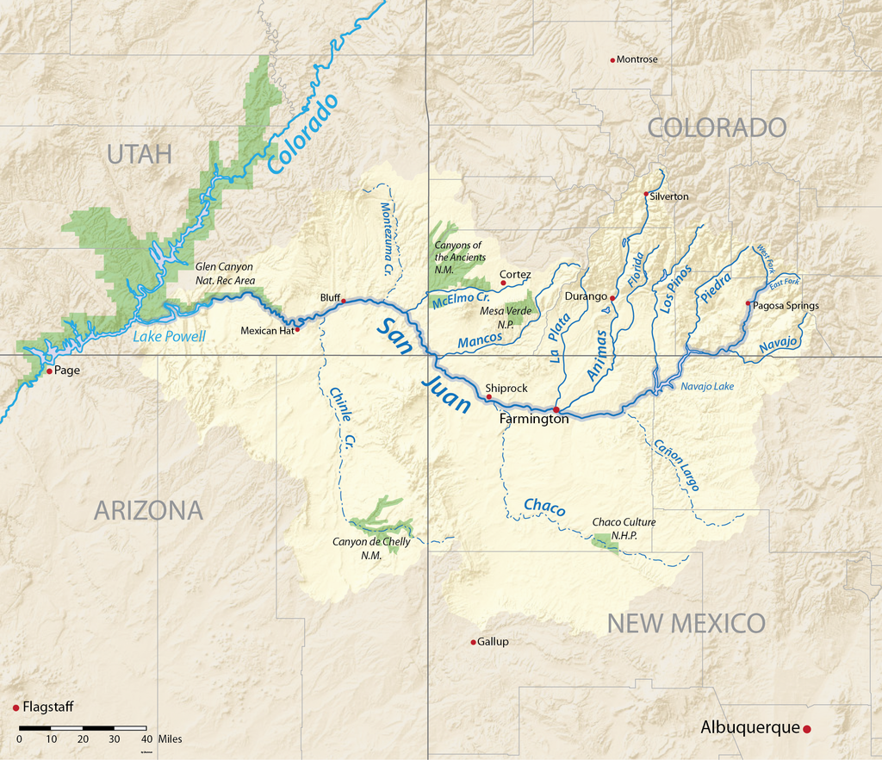
https://en.wikipedia.org/wiki/San_Juan_River_(Colorado_River)#/media/File:Sanjuanrivermap-new.png

- North Platte
  - Flows south to north just west of the Medicine Bow Mountains in north central Colorado. This river links up with the South Platte in Nebraska after flowing through Wyoming.
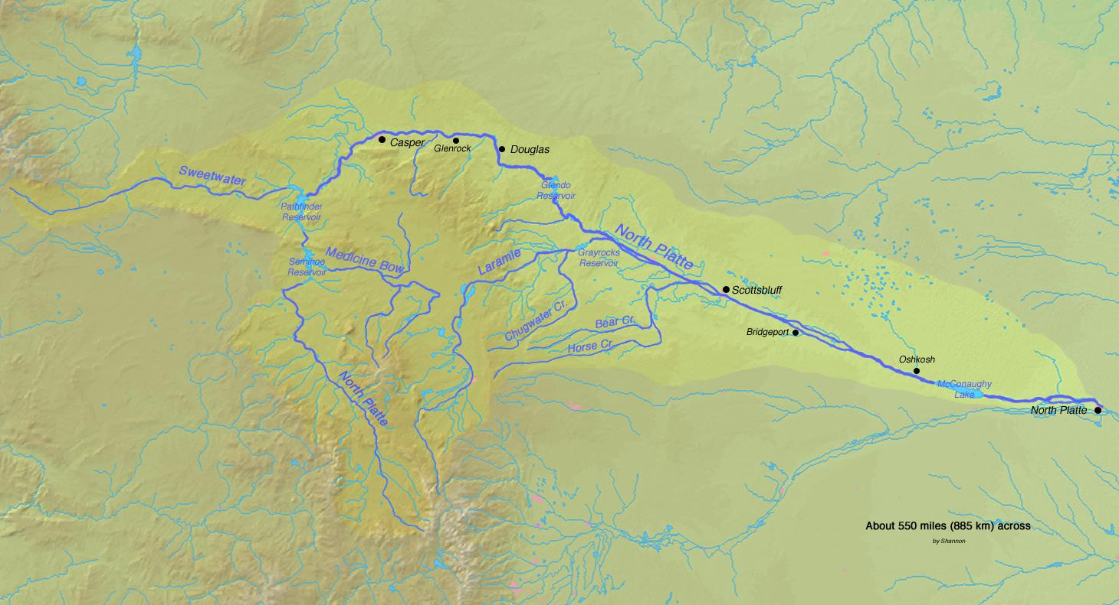
https://en.wikipedia.org/wiki/North_Platte_River#/media/File:Northplatterivermap.jpg

- Rio Grande
  - Begins in the San Juan Mountains and flows southeast toward Monte Vista and Alamosa in south central Colorado. 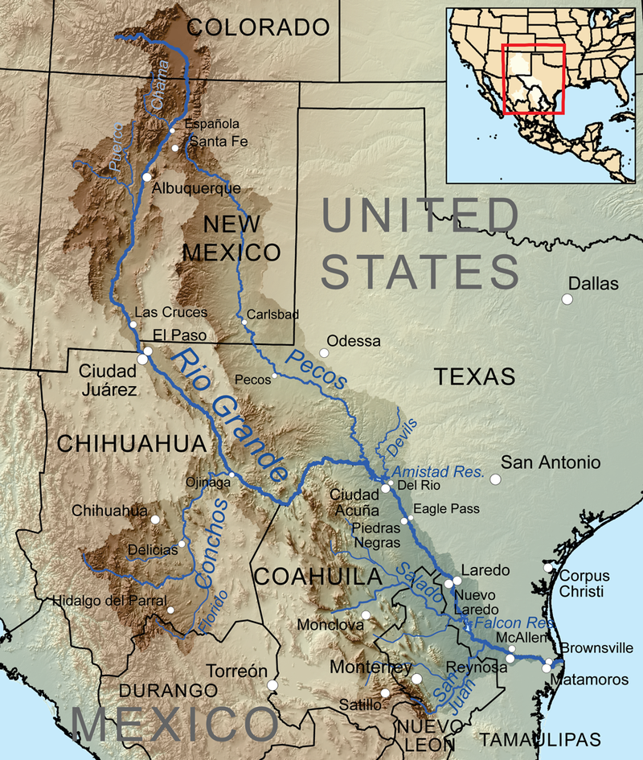
https://en.wikipedia.org/wiki/Rio_Grande#/media/File:Riogranderivermap.png

- Yampa
  - Begins on the White River Plateau in northwestern Colorado flowing north and then west.
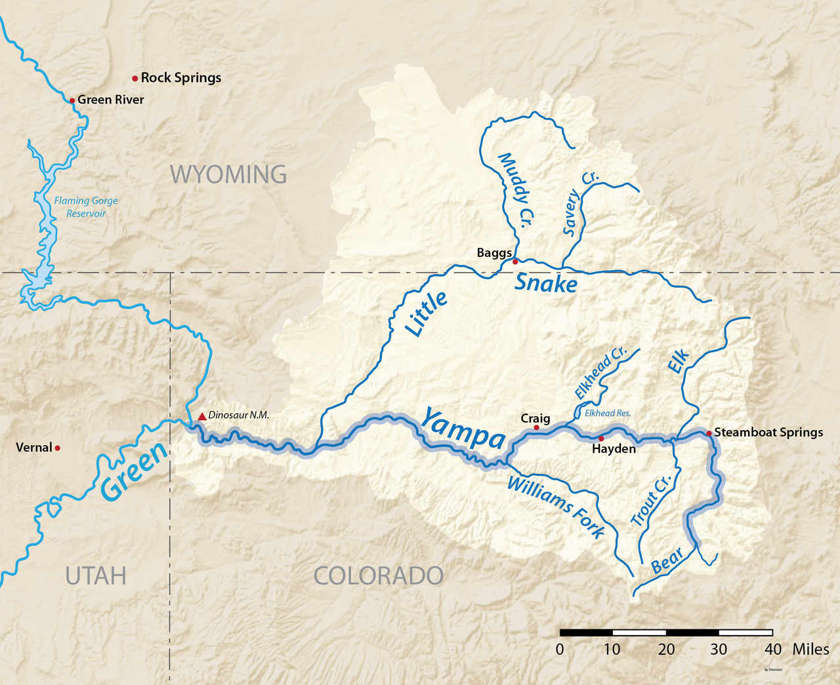
https://en.wikipedia.org/wiki/Yampa_River#/media/File:Yamparivermap.png

- Colorado
  - Begins in Rocky Mountain National Park, flows through Grand Lake (not labeled on the Giant Map), west through Glenwood Springs, and then through Grand Junction.
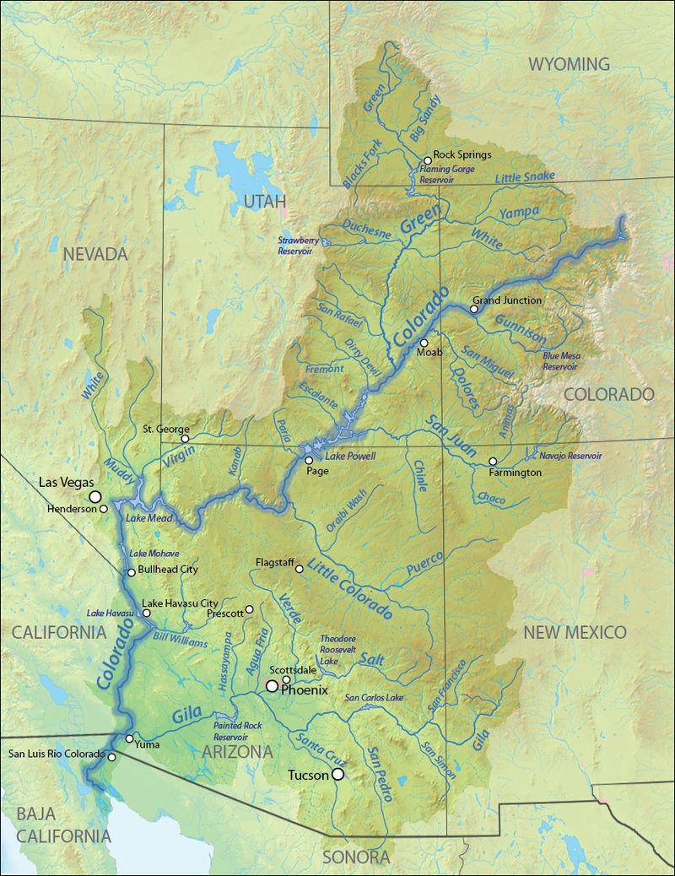
https://en.wikipedia.org/wiki/Colorado_River#/media/File:Coloradorivermapnew1.jpg

- Gunnison
  - It is not labeled on the Giant Map. It begins east of the town of Gunnison and flows through Blue Mesa Reservoir, through Delta and converges with the Colorado at Grand Junction.
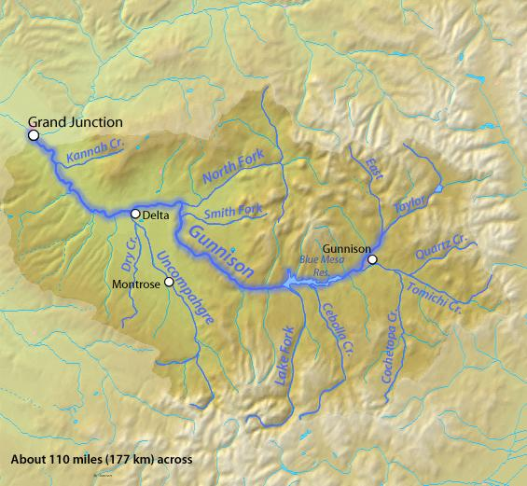
https://en.wikipedia.org/wiki/Gunnison_River#/media/File:Gunnisonrivermap.jpg

- Arkansas
  - Begins north of Leadville and flows southeast through Pueblo and then continues east through Las Animas and toward Lamar.
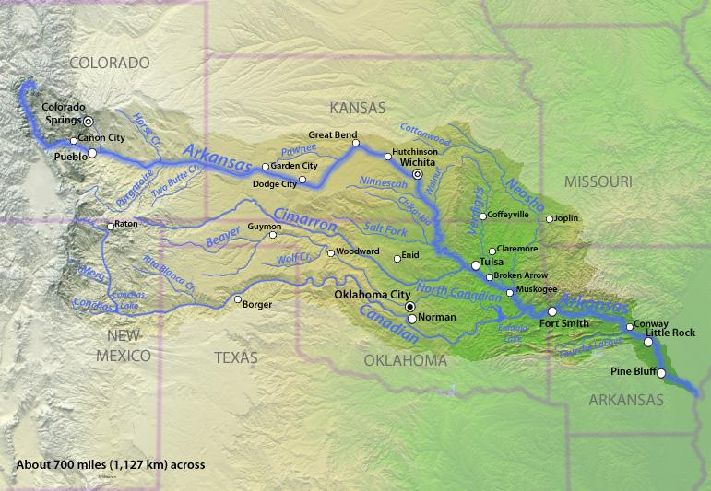
https://commons.wikimedia.org/wiki/File:Arkansasrivermap.jpg

- South Platte
  - Begins west of Woodland Park and flows through many small reservoirs while flowing north toward Denver, then on to Greeley, and east toward Sterling. It links up with the North Platte River in Nebraska.
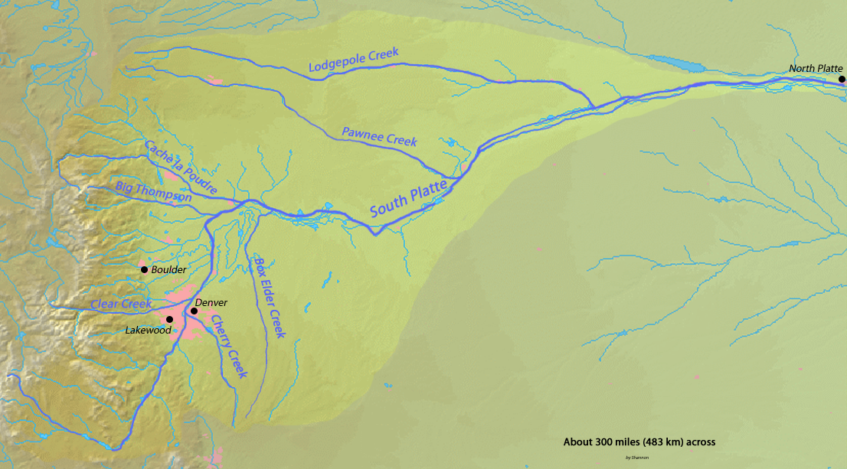
https://en.wikipedia.org/wiki/South_Platte_River#/media/File:Southplatterivermap.png

