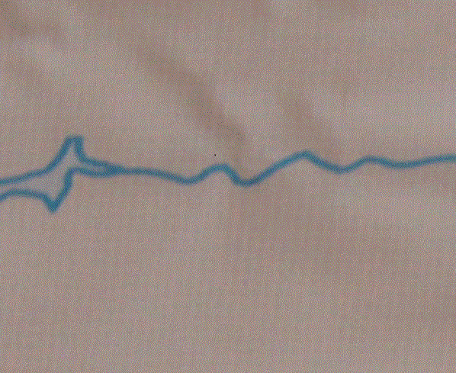  San Juan  Flows north to south east of Pagosa Springs in southwestern Colorado | North Platte  Flows south to north just west of the Medicine Bow Mountains in north central Colorado
Rio Grande  Begins in San Juan Mountains and flows southeast toward Monte Vista and Alamosa in south central Colorado | Yampa  Begins on the White River Plateau in northwestern Colorado flowing north and then west
Colorado  Begins in Rocky Mountain National Park, flows through Grand Lake, west through Glenwood Springs, and then through Grand Junction | Arkansas  Begins north of Leadville and flows southeast through Pueblo and then continues east through Las Animas and toward Lamar
Gunnison  Begins east of the town of Gunnison and flows through Blue Mesa Reservoir, through Delta and converges with the Colorado at Grand Junction (not labeled on map) | South Platte  Begins west of Woodland Park and flows through many small reservoirs while flowing north toward Denver, on to Greeley, and east toward Sterling, meeting the North Platte.

Print on blue card stock
Laminate
Cut into quarters

