Giant Map of Colorado Materials 2018

Material to download from National Geographic website (also on google site)
https://www.nationalgeographic.org/education/giant-maps/activities/
Colorado map key 11 x 17, 4 laminated
Scavenger hunt cards 11 x 17, 4 laminated
Scavenger hunt cards 8½ x 5½, 40 laminated
National Geographic Lesson Collection, 1

Material to download and prepare from Colorado Geographic website
Rules and Expectations Card, 1 laminated (add your contact information and logo)
Map folding instructions, 1 laminated
Compass rose pages, 4 laminated
Colorado State Outline Maps 8½ by 11, 40 laminated [https://www.nationalgeographic.org/education/mapping/outline-map/]
Elevation cards, 15

City cards
Avon
Bayfield
Beulah
Black Hawk
Broomfield
Buena Vista
Campo
Castle Pines
Cedaredge
Cherry Hill Village
Clifton
Collbran
Crested Butte
De Beque
Dolores
Dove Creek
Eagle
Edwards
Ellicott
Erie
Evergreen
Falcon
Franktown
Fraser
Fruita
Galeton
Golden
Granby
Gypsum
Haxtun
Hayden
Highlands Ranch
Hotchkiss
Ignacio
Indian Hills
Julesburg
Keenesburg
Kremmling
Lafayette
Lakewood
Louisville
Mancos
Manitou Springs
Merino
Miliken
Monument
Northglenn
Norwood
Otis
Ovid
Paonia
Parker
Peetz
Peyton
Platteville
Pritchett
Security-Widefield
Silverton
Superior
Walden
Walsh
Windsor

River cards
Arkansas
Colorado
Gunnison
North Platte
Rio Grande
San Juan
South Platte
Yampa

Railroad tracks
Standard gauge, 60
Narrow gauge, 60
Colorado railroad maps, 4 laminated
Colorado topographical maps, 4 laminated
Habitat pages, 7 laminated
Animal photo and description pages, 11 laminated
Landform cards, 14 laminated

Materials available for free from state organizations
Colorado Parks & Wildlife Habitat Posters (recommend lamination), 8
[http://cpw.state.co.us/learn/Pages/TR-Biodiversity.aspx
History Colorado State Register of Historic Properties cards, 63 [Erika.Warzel@state.co.us 303-866-4683]
Road maps of Colorado/Wyoming, 25 [try AAA, local tourist offices]

Materials from restaurant supply store
Metal menu holders, 64

Materials available from hardware stores such as Lowe’s or Home Depot – sizes approximate
Plastic 19 x 22 x 44 inch trunk with lid and wheels for materials, 1
Plastic 36 x 16 x 6 inch box with lid for map, 1
Plastic tubs with lids for materials, 4 (size depends on the size trunk)
Plastic nail tub for glass droplets, 1
Short-handled broom, 1

Items you probably have on hand
Manilla folders, 10 (for covering outlets or other hazards on the floor under the map)
Plastic compass, 1 (handy to figure out which way to set up the map in a large space)
Pads of sticky notes, 4 (colors to match large dots on map)
Ball of yarn, 1

Materials that may be available at big box or sporting goods stores
Pairs of socks, 6 (or more)
Laundry bag for stacking blocks, 1
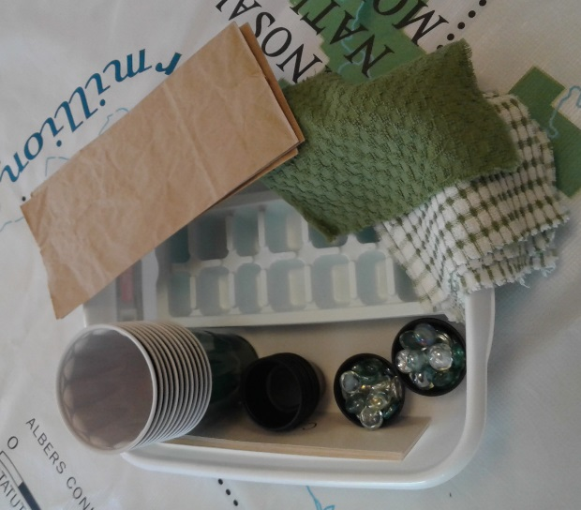
Reading Maps Together supplies (get extra for resupply)
- Stacks of green plastic drink cups, 96
- Tub of small glass droplets, 1
- Green squares of cloth, 12
- Green and white squares of cloth, 24
- Black plastic portion cups, 80
- Ice cube trays, 18
- Small, flattened brown paper bags, 24
- Cardstock strips with features written on them (6 of each):
  - mountain, river, grassland, small town, city, forest
  - Spanish or other language on reverse
- Blank cardstock strips, 6
- “shoebox” tubs, 6

Materials from a school supply or big box store
Tall colored cones, 15
Medium colored cones, 15
Flat colored cones, 15
Whiteboard, 1
Whiteboard marker, 1
Spanish-English dictionary, 1
Three-ring notebook for lessons and other information, 1
Placemat size map of the world and the United States, 10
Blow-up globe, 1
Dice, 4 different colors
Plastic bags or containers for stacking blocks, 4
Stacking blocks, size of duplos: Red, 125; Green, 111; Blue, 111; Yellow, 115

Chains: Black, Blue, Green, Orange, Pink, Red, White, Yellow [cut to length for each river]
Arkansas 16’ 2” Gunnison 6’ 5” Rio Grande 7’ 4” South Platte 18’
Colorado 12’ North Platte 4’ 3” San Juan 9’ 2” Yampa 11’ 5”

Potential suppliers

Plastic chains – 1 ½ inch links
https://www.stanchiondepot.com/crowdcontrolsafety.html

http://www.plastic-chain.com/

http://www.plasticchainlink.com/product-category/plastic-chain/ring-plastic-chain/
http://www.plasticchainlink.com/product-category/plastic-chain/box-plastic-chain/

Plastic cones
http://www.gophersport.com/pe/teacher-resources-cones-markers/rainbow-plastic-cones?gclid=CLvo95u_1M8CFQiJaQodikoOdQ

http://playground.epicsports.com/productsearch.html?term=cones
