Springfield 4,360 ft. A  Trinidad 6,010 ft. B  Canon City 5,331 ft. A  Sangre de Cristo 14,351 ft. D  Mountains | Alamosa 7,543 ft. B  Pueblo 4,692 ft. A  Great Sand Dunes 13,604 ft. D  National Monument  Salida 7,083 ft. B
Pawnee National 5,230 ft. A  Grassland  Fort Collins 5,003 ft. A  Greeley 4,658 ft. A  Sterling 3,875 ft. A | Boulder 5,430 ft. A  Colorado Springs 6,035 ft. B  Woodland Park 8,465 ft. C  White River Plateau 10,000 ft. C
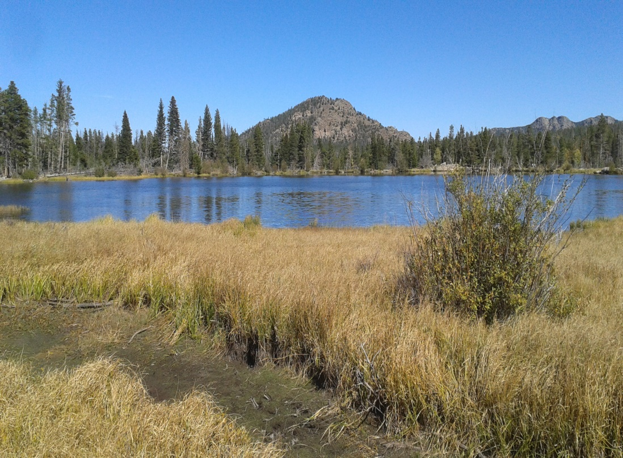
Pagosa Springs 7,126 ft. B  Telluride 8,750 ft. C  Mesa Verde National 8,572 ft. C  Park and Preserve  Durango 6,512 ft. B | Gunnison 7,700 ft. B  Uncompahgre Plateau 9,500 ft. C  Black Canyon of the 8,320 ft. C  Gunnison National Park  Montrose 5,807 ft. A
Leadville 10,200 ft. C  Rampart Range 9,632 ft. C  Vail 8,022 ft. C  Glenwood Springs 5,761 ft. A | Grand Mesa 11,332 ft. D  Roan Plateau 9,200 ft. C  Rangely 5,297 ft. A  Burlington 4,170 ft. A
Park Range 12,182 ft. D  Dinosaur National 5,900 ft. A  Monument  Meeker 6,240 ft. B  Craig 6,198 ft. B | Denver 5,280 ft. A  Steamboat Springs 6,732 ft. B  Rocky Mountain 14,439 ft. D  National Park  Estes Park 7,522 ft. B
Rocky Ford 4,180 ft. A  Walsenburg 6,171 ft. B  Limon 5,377 ft. A  Pikes Peak 14,114 ft. D | Akron 4,659 ft. A  Fort Morgan 4,324 ft. A  Longmont 4,984 ft. A  Mt. Elbert 14,439 ft. D
Grand Junction 4,593 ft. A  Colorado National. 7,000 ft. B  Monument  Rifle 5,348 ft. A  Orchard City 5,446 ft. A | Aspen 8,000 ft. C  Gore Range 13,534 ft. D  Blue Mesa Reservoir 7,519 ft. B  Delta 4,953 ft. A
Aurora 5,471 ft. A

Castle Rock 6,224 ft. B

Kiowa 6,378 ft. B

Last Chance 4,820 ft. A

Add important places in your region on the extra card.
Print on light colored card stock, with or without photos on back.
Laminate.
Cut into quarters.

