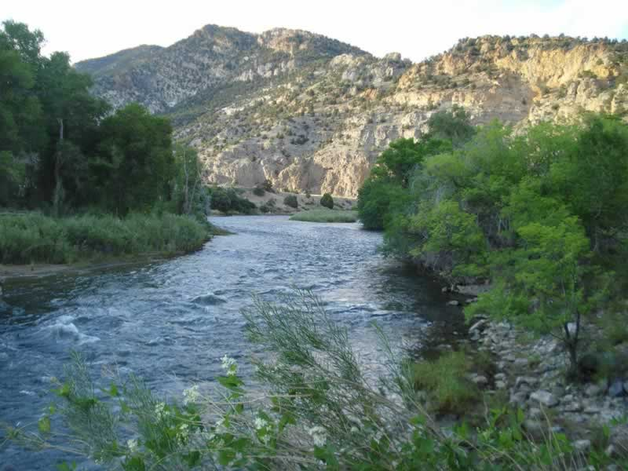
Landform Description 1

- Melted snow moves down the mountains and across the plains
- Bushes and trees like to grow here because of the water
- Fish and ducks live here. Other animals visit.

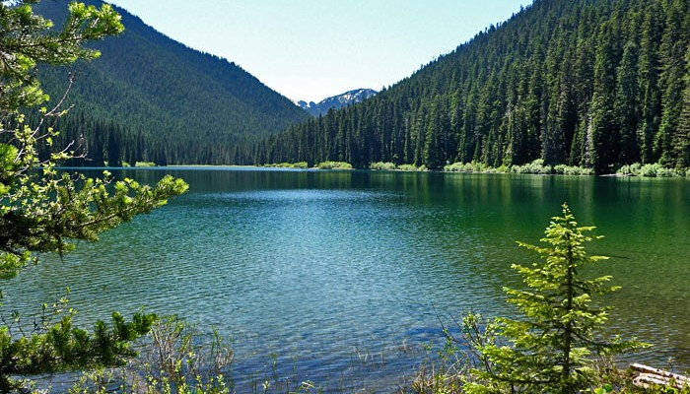
Landform Description 2

- Water gathers here.
- Trees, reeds, and water plants grow here.
- Fish, ducks, and blue heron live here. Other animals live close by.

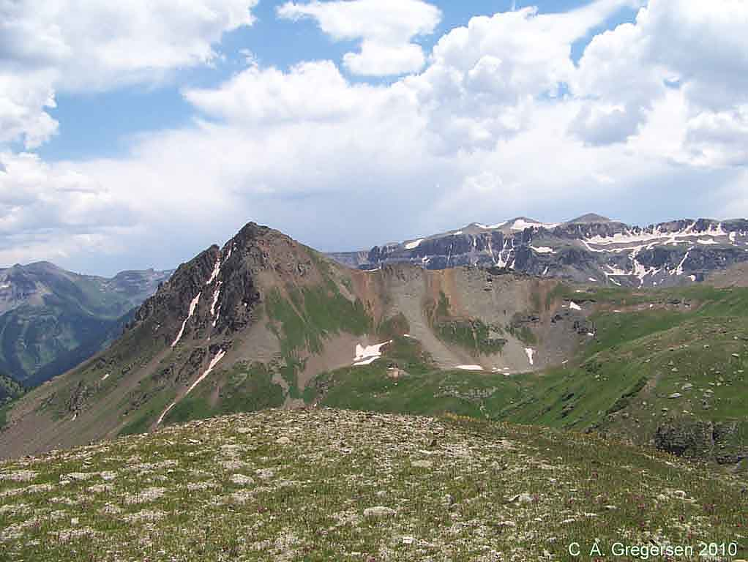
Landform Description 3

- It is too cold to live here in the winter. In the summer, marmots, pika, big horn sheep, and mountain goat can be seen here.
- This area gets lots of snow in the winter. It can even snow here in the summer.
- Trees do not grow here due to the harsh weather. Very short, flowering plants grow here in the summer.

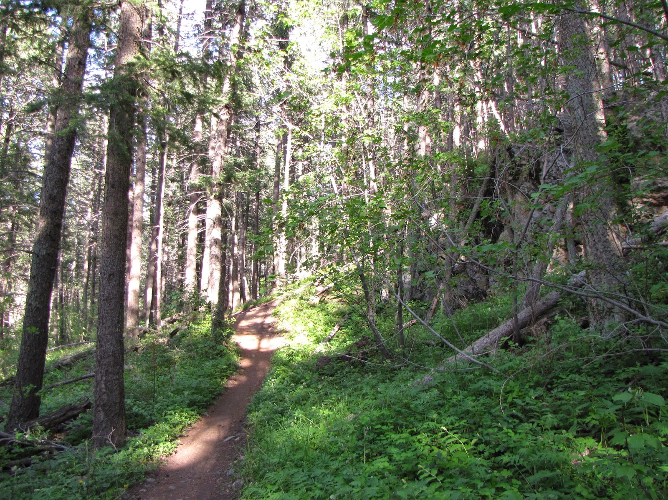
Landform Description 4

- The trees here offer many places for animals to live. You will see many tall pine trees and aspen here.
- Rivers and lakes are available to drink.
- Squirrels, birds, bear, wild cats, coyote, rabbits, and elk live in this area.

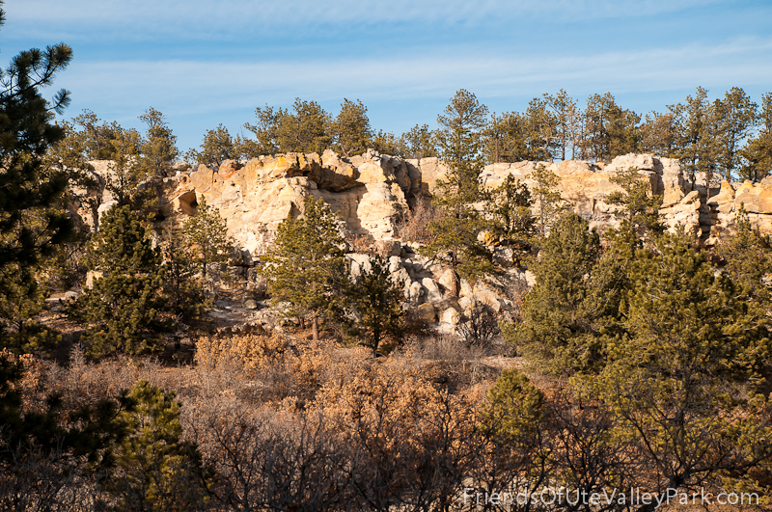

Landform Description 5

- The trees here are short and scarce. Bushes and grasses also grow in this dry area.
- Deer, coyote, rabbits, lizards, and snakes live here.
- This hilly area leads up to the mountains.

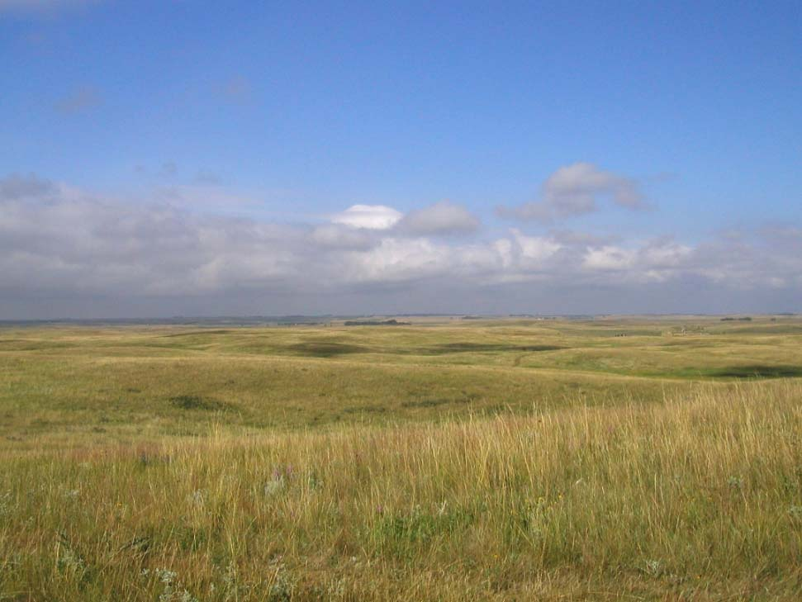
Landform Description 6

- Lots of grass grow here. Few trees grow here.
- Smaller animals live here. You might see coyote, fox, rabbit, squirrel, and mice.
- Birds, like hawks, hunt in this grassy area.

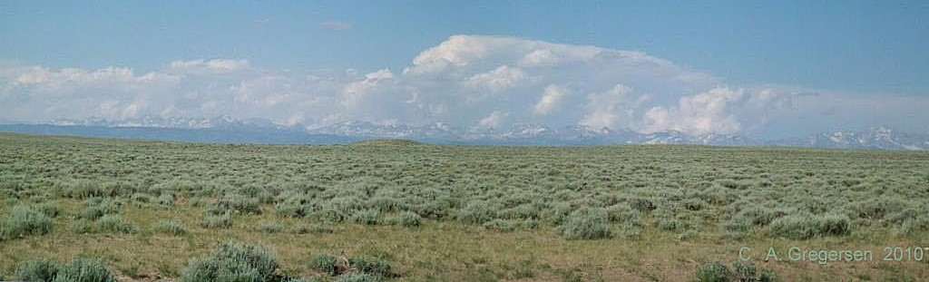

Landform Description 7

- Small shrubs grow in this semi-desert area.
- Cactus and yucca grow here. Few trees grow here.
- Similar to the grasslands, wild cats, coyote, fox, squirrels, and mice live here.

