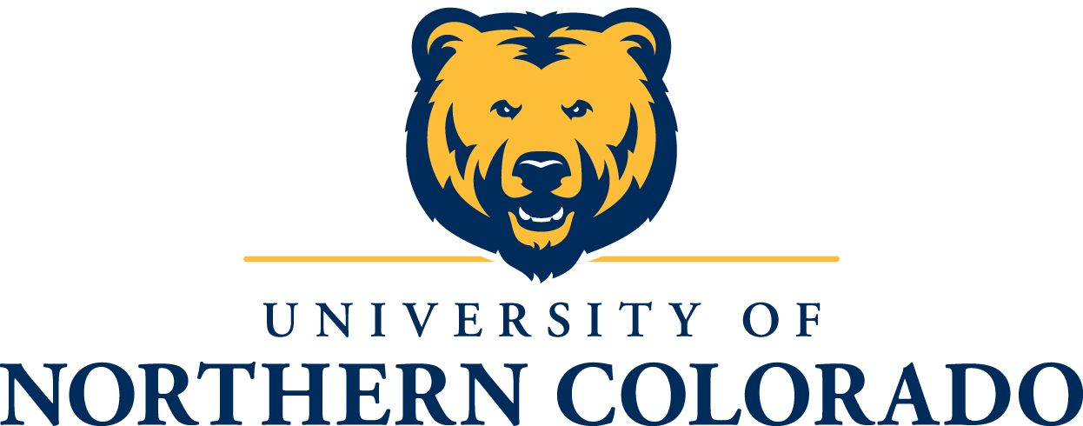

Office of Student Clubs and Organizations
Event Follow-Up Form
Please submit via email to clubs@unco.edu

Name of Club or Organization:_____________________________________________________

Name of Event Held:____________________________________________________________

Date the event was held: _____/______/________

Number of people in attendance: __________

- What were the main 3 objectives of this program and does your club feel that the three objectives were met?

- What aspects of your event were successful?

- What aspects of your event could be improved upon?

- What steps will your organization take to ensure more successful events in the future?

Amount of Student Fees Allocated for the event: $______________

Amount of Student Fees used $______________
**This MUST be accurate information. Please review the receipts from the event.

**Student Fee money only
Program Expenses | Description of Expense | Expense/Cost of item | Total
Speaker Honorarium |  |  | $0.00
Room/Space Rental |  |  | $0.00
Tech Services |  |  | $0.00
Food/Catering for event |  |  | $0.00
Other Expenses |  |  | $0.00
Other Expenses |  |  | $0.00
Other Expenses |  |  | $0.00
Total Programming |  |  | $0.00
Advertising | Description | Expense/Cost of item | Total
Connection/Mirror Ad |  |  | $0.00
Posters/Flyers |  |  | $0.00
Poster Run Fees |  |  | $0.00
Ticketing/I-Box Set up Fees |  |  | $0.00
Informational Brochure |  |  | $0.00
Other Marketing Expense |  |  | $0.00
Other Marketing Expense |  |  | $0.00
Total Advertising |  |  | $0.00
Complete Total
$0.00

