**Nondegree Seeking Application**

* Overall apply page: [unco.edu/apply/](https://www.unco.edu/apply/)

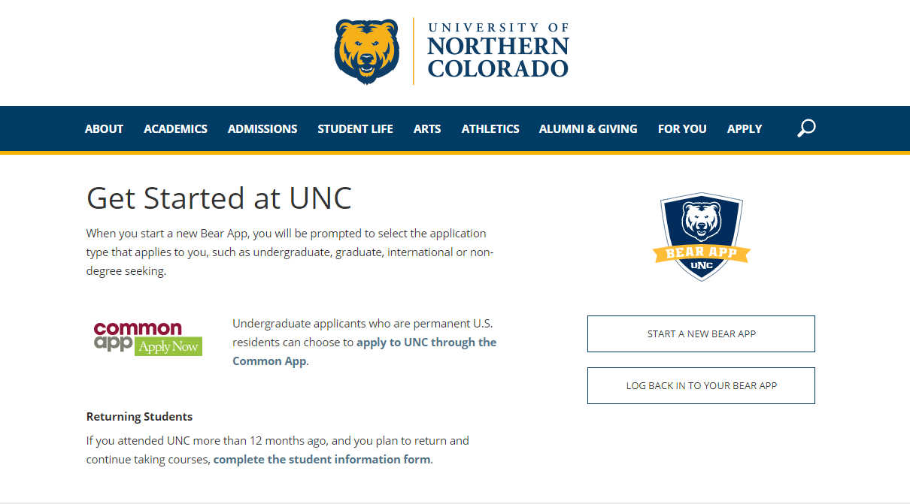

* Click **START A NEW BEAR APP**

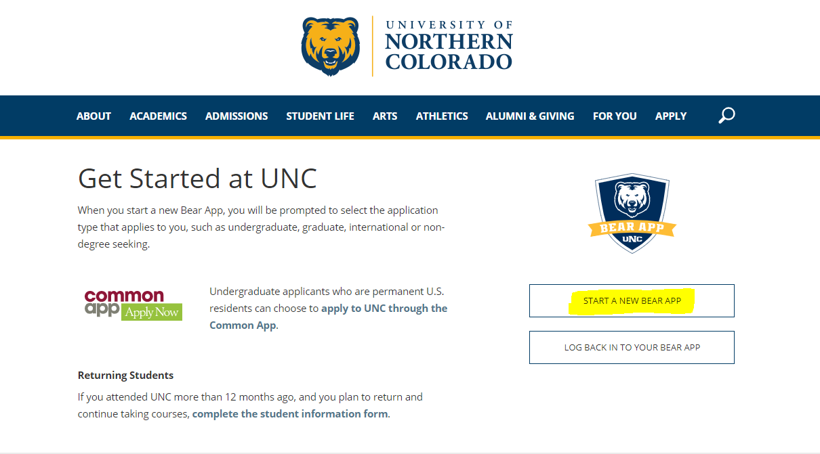

* You will be directed to a page that looks like this:

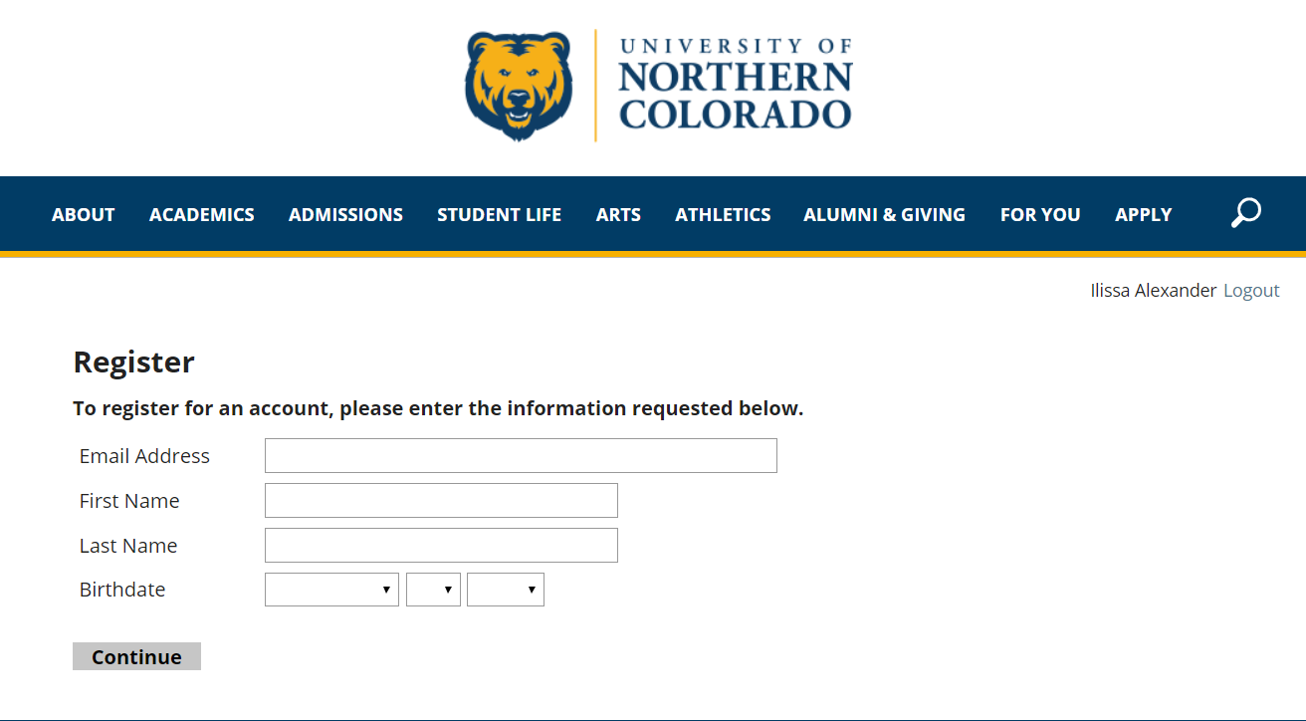

* Complete all of the fields listed above & click **Continue** to begin the application process:

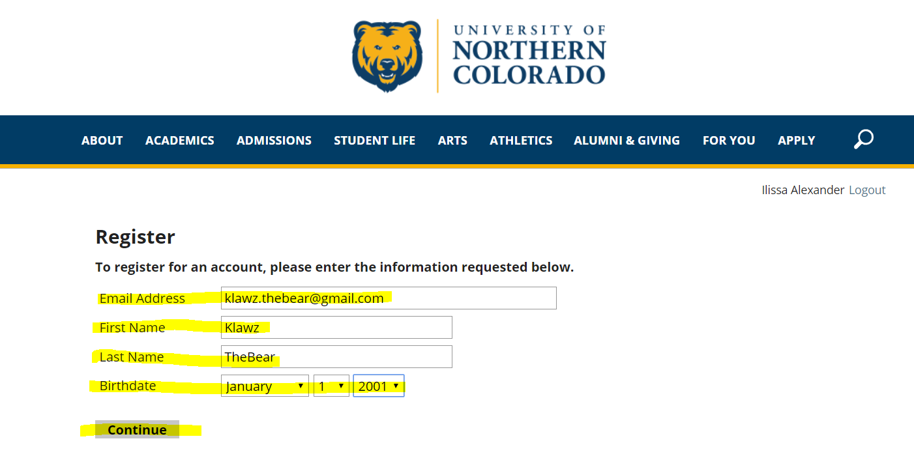

* When you hit “Continue”, you will see the page below AND will receive an email at the email address you listed in the screen above:

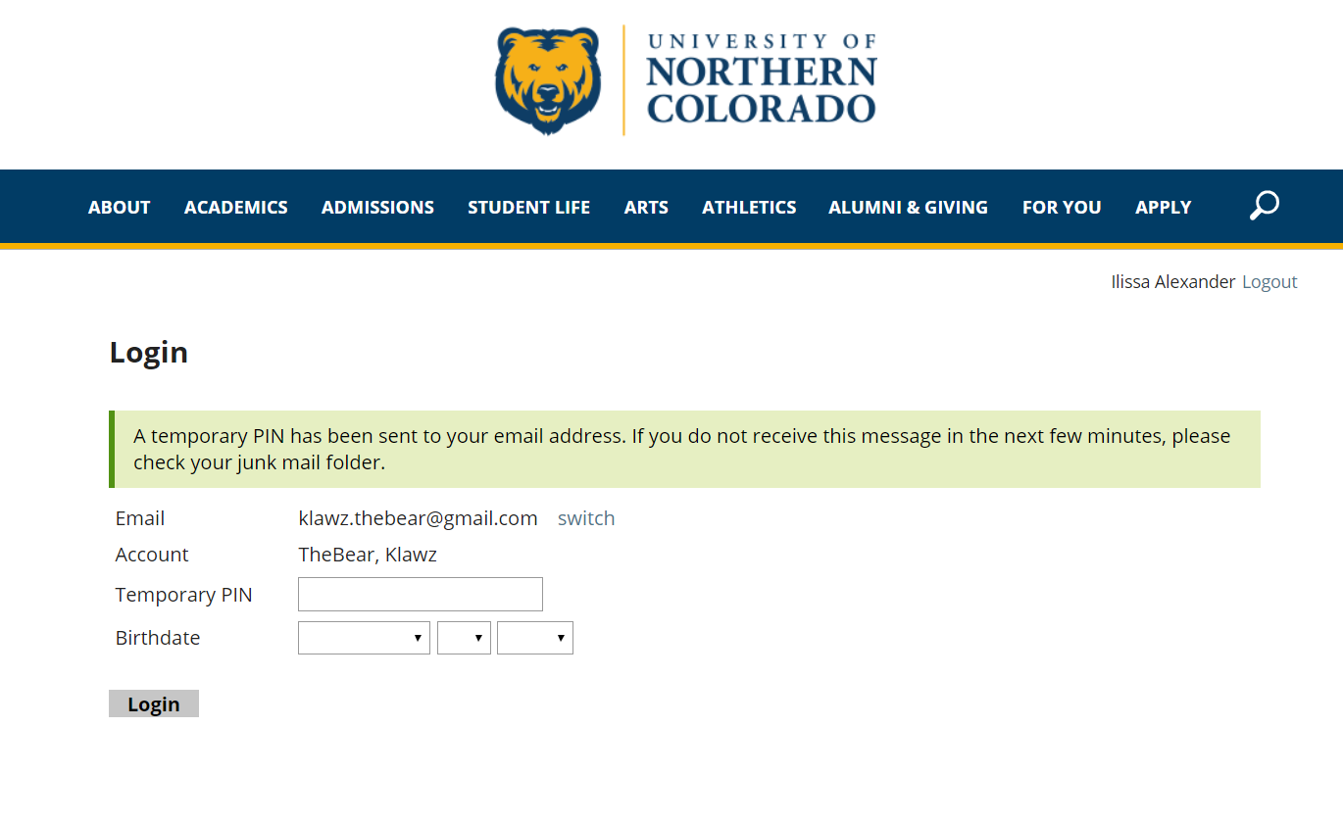

* The email will look like this:

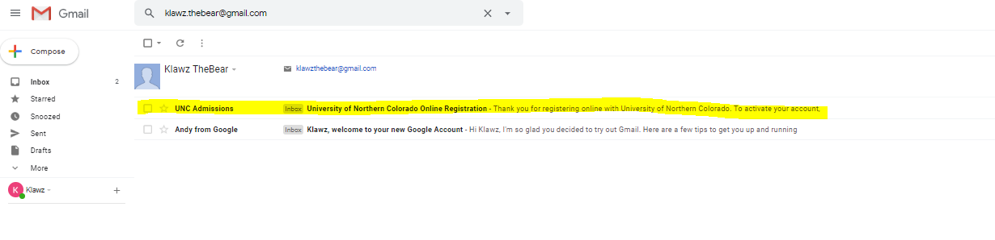

Below is what the email says:

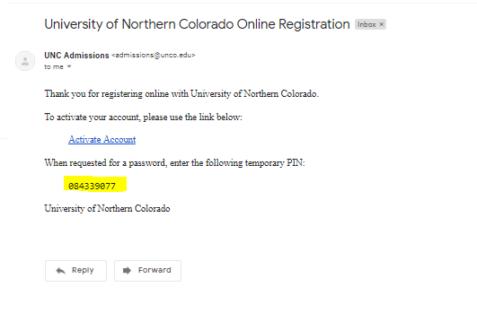

* Click on the Activate Account link in the email. You will enter the **Temporary PIN** received in the email and your **Birthdate** before clicking **Login**.

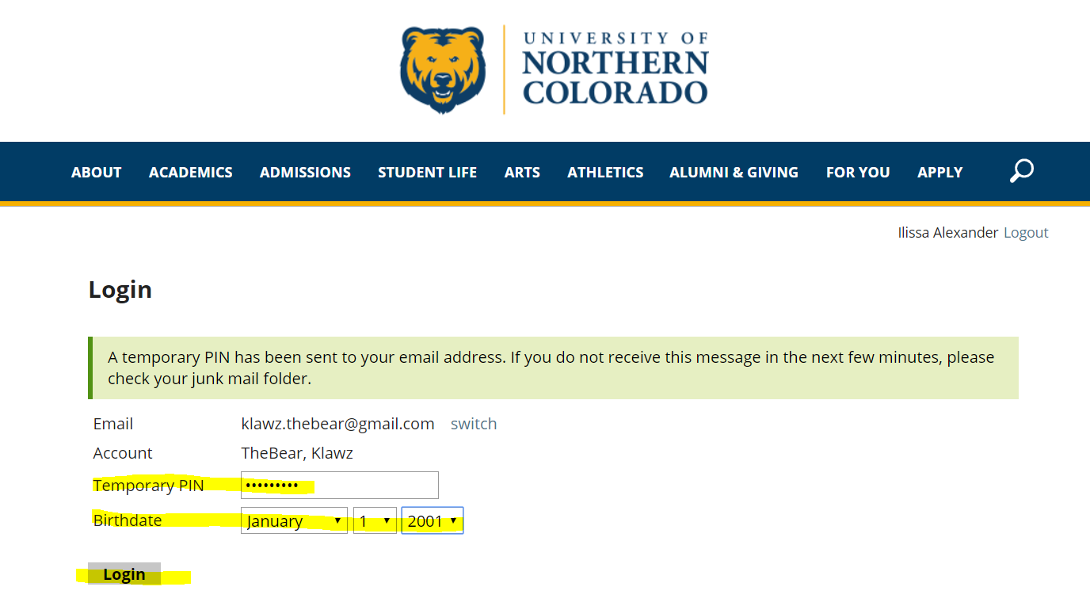

* At this point, you’ll set a password for the application:

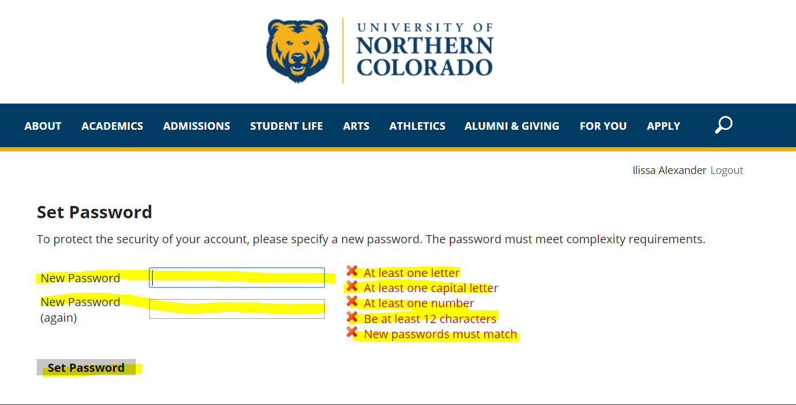

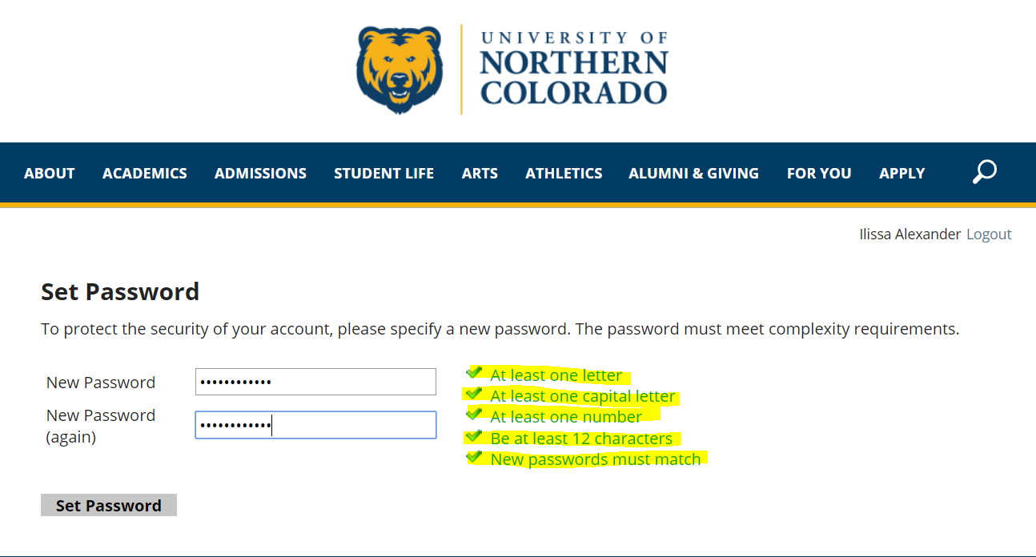

* After creating a password, you will see the page below and will choose the Non Degree Seeking

Application option. To begin, click “**Start New Application”** at the bottom of the page.

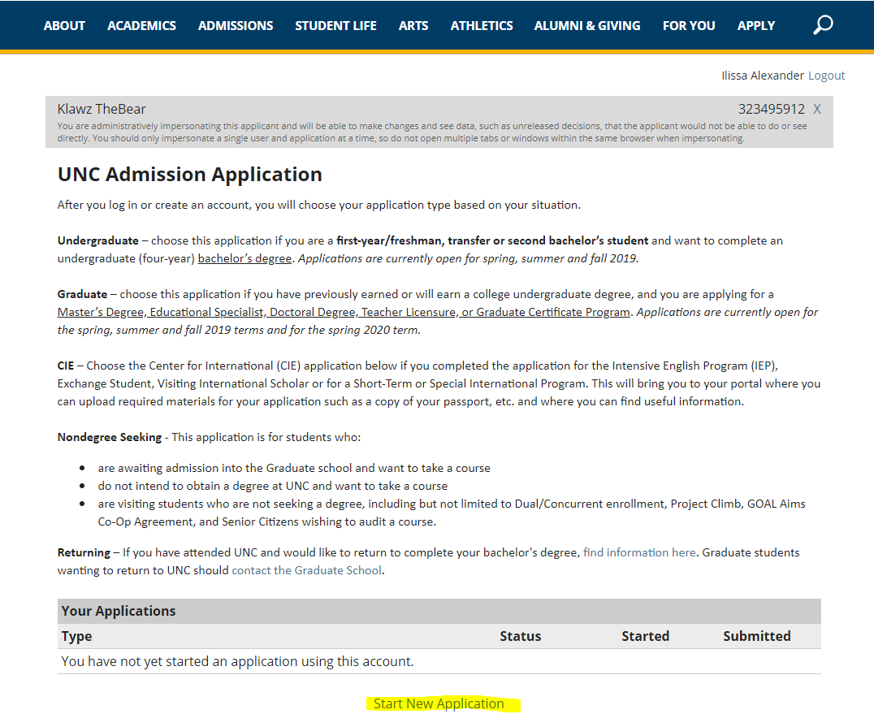

* An application-type dialog box pops up. As a Nondegree seeking student, you’ll select **2021 (or current year) Nondegree Seeking**.

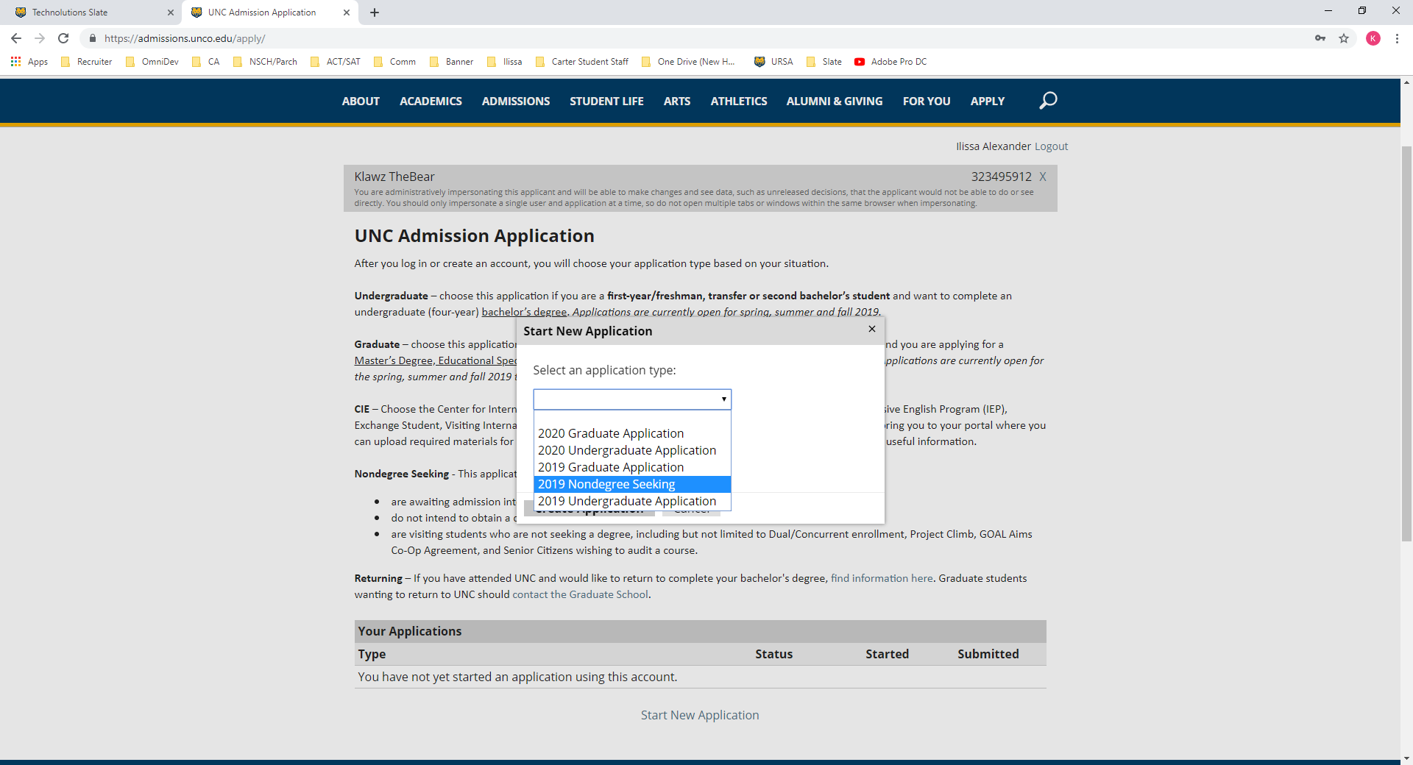

Once **2021 (or current year) Nondegree Seeking** has been selected (twice, there are two dialog boxes), click **Create Application (ignore the 2019 designation below, you choose the current year)**:

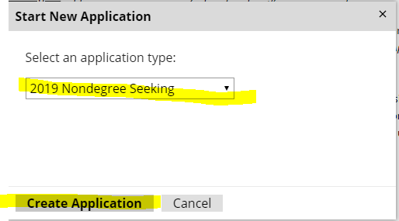

* Then click **Open Application**.

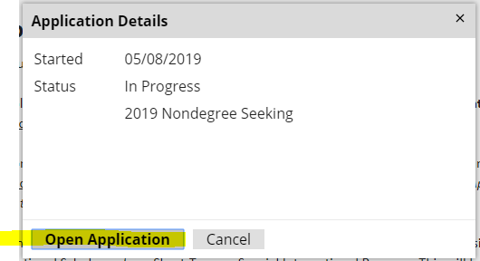

* This takes you to the first page of the Nondegree Seeking application where you can select **Mentor Teacher** as the type of application.

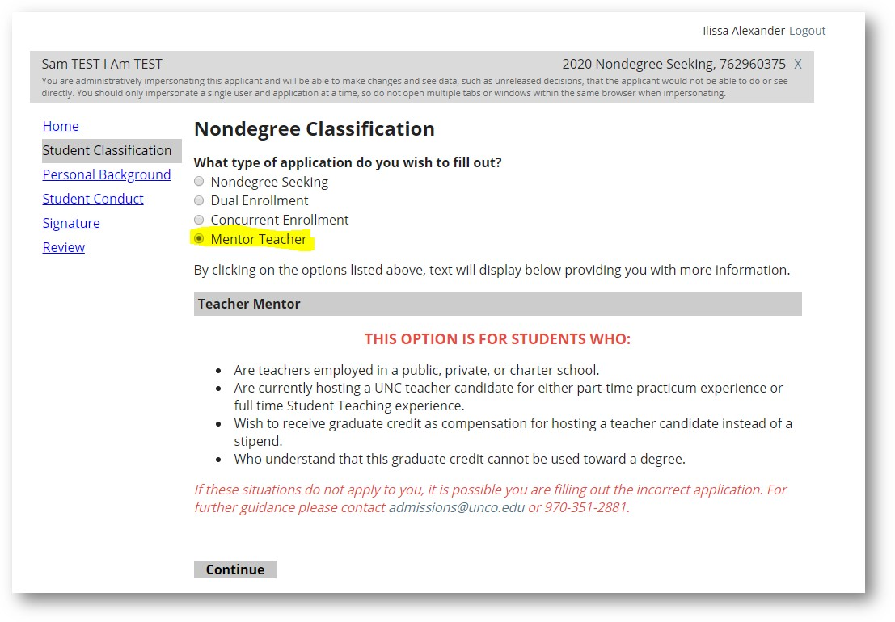

From there, fill out all the appropriate fields on the application.

* Legal First Name
* Legal Last Name
* Permanent Address
* Provide one telephone number
* Sex
* Birth Country
* Citizenship
* Are you Hispanic or Latino?
* Term
* Have you registered for the selective service?
* Have you earned a bachelor’s degree?
* Was your bachelor’s degree awarded from UNC?
* How many teacher candidates are you hosting?
  + Please list their name(s)
* Are you hosting a special education teacher candidate?
* Residency questions

Next fill out the **Conduct** and **Certify** portions of the application:

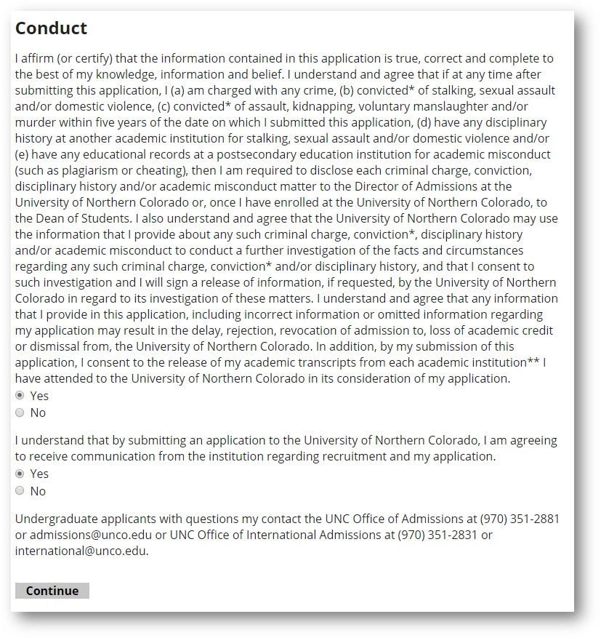

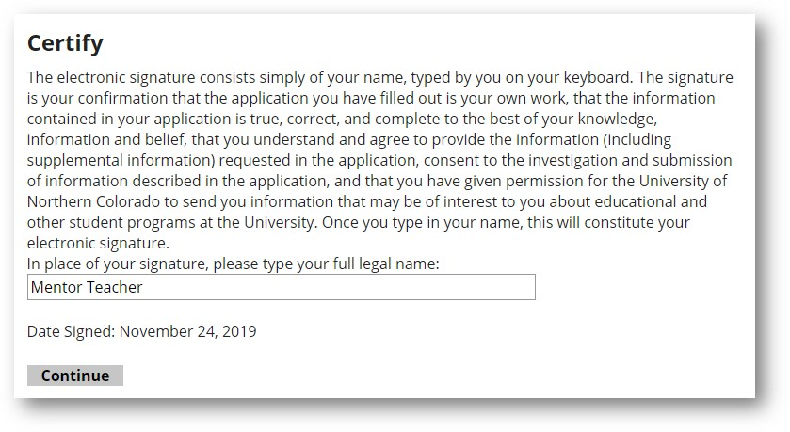

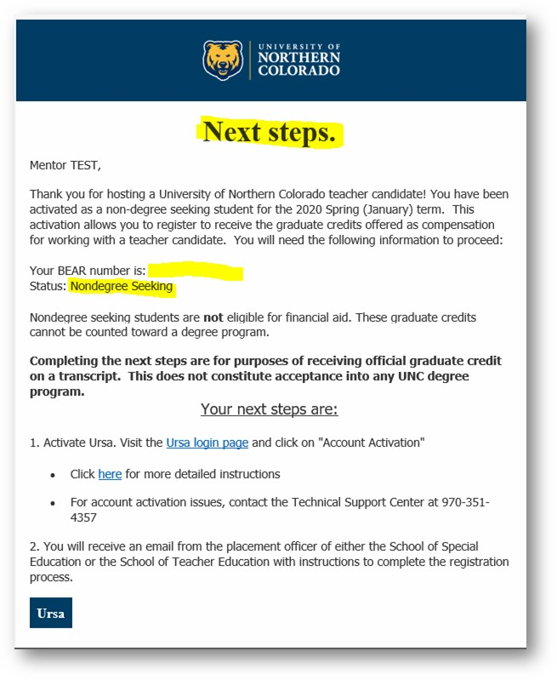Once the application is processed, you will receive an email from the Admissions Office with your student account info. **The account creation process may take up to 72 hours, it is very important you begin the process several days before the course add deadline.** Activate your account as instructed. You will then receive an email from the Placement officer for either the School of Teacher Education or the School of Special Education with instructions to register for the credit.