Field Experience State Fingerprint/Background Process
All teacher candidates in licensure programs at UNC are required, by the State of Colorado, to complete the following fingerprint/background process before being allowed into any partner school for field-based work. This includes observations/work for courses (i.e. EDEC 250, EDEL 360, STEP 161, STEP 262, EDFE 170, etc.), practicums (EDEL 457, EDEL 459, EDEC 464, STEP 363, EDFE 370, EDFE 501, etc.) and final student teaching.
Failure to complete this process could delay your program as you will not be allowed in partner schools without it.

There are three (3) steps you must complete:
- Create your lifetime account in the COOL system with the Colorado Department of Education (CDE).
- Schedule and complete your fingerprinting appointment.
- Complete the online field experience background information form on the CDE website, after you complete your fingerprinting. (if this is not done before 30 days after fingerprints are taken – you will have to pay to re-do your fingerprints – that’s $49.50 again!)

Specific details for each step are as follows:

1. Create your lifetime account in the COOL system with Colorado Department of Education (CDE).
If you do not complete this step, CDE will not have your account to file the background check results in and you may need to repeat (and pay for again) the process after you have created this account.
- Use this link: https://cool.randasolutions.com/Account/Login?ReturnUrl=%2F
- Click on ‘register’ and complete the required fields.
- **You must have a social security number**
- It is recommended you use a personal email for this account, not your Bear Email.

2. Schedule a fingerprinting appointment at an approved vendor site. Be sure to use the appropriate service code, highlighted below for each vendor. These are the only authorized vendors:
IdentoGo
Colorado Locations: Yes
Nationwide Locations: Yes
Mobile Fingerprinting: Yes, for groups of 30 or more people. Contact the vendor for details.
Service Code/Unique ID: 25YQZV - Clicking the link above will automatically initiate the process to schedule your fingerprint appointment at an IdentoGO enrollment center.
Mail-in Card Conversion Service: Yes. Click here and then click on the link titled "Submit a Fingerprint Card by Mail."
Payment Process: Pay at your service appointment, no payment is necessary when you pre-enroll. If you need to cancel your appointment, open the email that you received at the time you booked the appointment, click on the link to check your status and then click the "Cancel Appointment" link.

American Bioidentity Inc./Colorado Fingerprinting*
Colorado Locations: Yes
Nationwide Locations: No
Mobile Fingerprinting: Unknown, contact vendor.
Service Code/Unique ID: 6188EPPI
Mail-in Card Conversion Service: Unknown, contact vendor.
Payment Process: Payment is due at time of pre-enrollment. Contact the vendor if you need to cancel your appointment and for their refund policy.
*Colorado Fingerprinting is a private company and is not a state agency.

- Complete the required program information in your COOL account. This must be done right AFTER you submit your fingerprints. Here is how to complete this step:
  - Log in to your COOL account (or create one and then log in) at https://cool.randasolutions.com
    - Your account must include your full legal name, date of birth and SSN.
  - Go to “My Profile.”
  - Select “Programs” under the Preparation section in the menu on the left.
  - Select “+ Add Program”
  - Complete the form in its entirety.
  - Select “Save” to submit.

Things you may need to know for step 3:
- The first email address asked for is the one you submitted when you set up your eLicensing account in step 1 above.
- Choose University of Northern Colorado for your Educator Preparation Program.
- Your School Identification Number is your UNC Bear Number, NOT the number on your UNC ID card!
- You will need to scan your UNC ID card and upload a copy.
- The next email address asked for is your UNC Bear Email only!
- The date your educator preparation program began is the date you started at UNC.
- The date you complete your program is your expected graduation date.
- You will be asked to list the school district or charter school where you will be placed for your field experiences. If you do not know, you should choose No Placement and leave the other 2 selections blank.
- Please select that you want notification of this form completion sent to your educator preparation program. You may also choose to have a copy of your responses sent to you. This is a good idea.
- Don’t forget to hit the SUBMIT button at the very end.

- - - - - - - - - - - - - - - - - - - - - - - - - - - - - - - - - - - - - - - - - - - - - - - - - - - - - - - - - -

In order to turn in the proper documents for your checkpoint course in Canvas, this is what the page should look like that you will need to submit with your other documents. This page is found in your dashboard under ‘My Profile’.
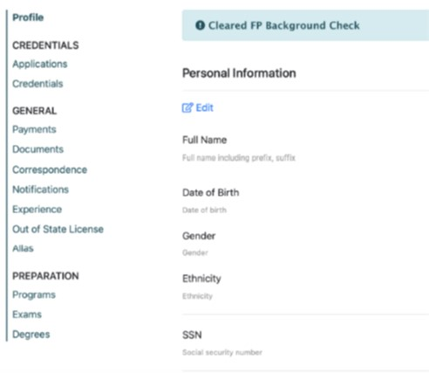

If you cannot find this page in your COOL account then please check this page to ensure you have completed all steps: https://www.cde.state.co.us/cdeprof/fieldexperience

